BLACK BOOK PROJECT REPORT ON
A STUDY OF THE INDIAN DEBT MARKET:
INSTRUMENTS, MARKET STRUCTURE, VALUATION AND TRADING
Submitted in partial fulfilment for the award of the degree of
MASTER OF MANAGEMENT STUDIES
FINANCE
UNIVERSITY OF MUMBAI
Submitted by
[SIDDHESH SHINDE]
ROLL NO: [M-16156]
[2025-2027]
Under The Guidance of

[DR. PRASAD SUPEKAR]
DES’S NAVINCHANDRA MEHTA INSTITUTE OF TECHNOLOGY
AND DEVELOPMENT, MUMBAI – 400028


CERTIFICATE
This is to certify that the black book project report titled “A Study of the Indian Debt Market: Instruments, Market Structure, Bond Valuation and Interest Rate Risk” submitted in partial fulfilment for MMS Degree Examination by Siddhesh Shinde is a record of research work carried out by the student during the period from 2026-2027 under my guidance, and has been found satisfactory. This project work is original and not submitted earlier for the award of any degree, diploma or associateship of any other University/Institute.

COLLEGE STAMP HERE

---------------------------  Dr. Rasika Mallya  DIRECTOR | ---------------------------  Dr. Prasad Supekar  PROJECT GUIDE
---------------------------
EXTERNAL EXAMINER


DECLARATION
I hereby declare that this project report submitted by me to the partial fulfillment of the requirement for the award of Master of Management Studies (MMS) of the University of Mumbai is a bonafide work undertaken by me and it is not submitted to any other University or Institute for the award of any degree, diploma/ certificate or published any time before.
Name : SIDDHESH SHINDE Signature
Roll No. M-16156 SIDDHESH SHINDE

ACKNOWLEDGEMENT
This project has been a tremendous learning experience, and I am truly grateful to everyone who has supported me along the way. First and foremost, I want to extend my deepest thanks to Dr. Prasad Supekar, my internal project guide. His/her invaluable guidance and thoughtful suggestions made this project possible. His constant support and encouragement have been a source of inspiration, helping me channel my enthusiasm effectively.
I am profoundly grateful to my parents, whose unwavering support and belief in me have
been my greatest strength. I also want to express my sincere thanks to my friends, who have
been incredibly committed and willing to help throughout my project work. I am deeply thankful to Dr. Rasika Mallya, Director of DES’s Navinchandra Mehta Institute of Technology and Development, for providing me the opportunity to work on this project and expand my knowledge and experience.
I would also like to extend my heartfelt thanks to all the professors and staff of DES’s NMITD especially the library staff, who were always helpful in providing the necessary books and articles for my project. I also acknowledge NSE Academy for the FIMMDA-NSE Debt Market (Basic) Module, which formed the basis of this study. Lastly, I am grateful to everyone who indirectly supported me and contributed to the success of this project. Your cooperation and invaluable support have been much appreciated.
Siddhesh Shinde
EXECUTIVE SUMMARY
The debt market is the largest and most important segment of the Indian financial system, yet it is one of the least understood by students of finance. This project, titled “A Study of the Indian Debt Market: Instruments, Market Structure, Bond Valuation and Interest Rate Risk”, studies the Indian debt market on the basis of the NSE Debt Market (Basic) Module of NSE Academy.
The project describes the features of debt instruments and the variations in coupon, maturity and principal repayment; the segments, participants and instruments of the market; the primary and secondary markets for Central Government securities, treasury bills and State Government bonds; the money market instruments, namely call money, commercial paper, certificates of deposit and repos; the market benchmarks i-BEX and MIBID-MIBOR; and the trading, settlement and regulatory framework.
The analysis shows that government securities form 56.19 per cent of the debt market capitalisation, that market borrowings financed 82.3 per cent of the gross fiscal deficit of the States in 2012-13, and that the Central Government is lengthening the maturity of its borrowing. The quantitative part works through bond valuation, yield to maturity, the yield curve, bootstrapping and duration, with every illustration recomputed and verified. The study finds that bond prices move convexly and inversely with yields, that the yield curve is upward sloping, and that duration is an accurate measure of interest rate risk for small changes in yield.
The report concludes with suggestions for deepening the corporate bond market, widening the investor base and improving liquidity, and lists the limitations of the study.

 |  | CONTENT | PAGE NO.
Chapter 1 |  | INTRODUCTION | 7
 | 1.1 | Need of the study
 | 1.2 | Objectives of the study
 | 1.3 | Scope of the study
 | 1.4 | Overview of the Indian debt market
 | 1.5 | Challenges of the Indian debt market
 | 1.6 | Structure of the report
Chapter 2 |  | ORGANISATIONAL BACKGROUND | 10
 | 2.1 | Organisational introduction
 | 2.2 | NSE Certification in Financial Markets (NCFM)
 | 2.3 | FIMMDA and its role
 | 2.4 | Mission and vision
 | 2.5 | Structure and content of the Debt Market module
 | 2.6 | Nature of the project work undertaken
Chapter 3 |  | THEORETICAL FRAMEWORK: DEBT INSTRUMENTS AND THE INDIAN DEBT MARKET | 14
 | 3.1-3.6 | Introduction; features of a bond; coupon, maturity and principal variations; asset backed securities
 | 3.7-3.9 | Market segments; participants; instrument matrix
 | 3.10-3.12 | Secondary market; Central Government securities; primary dealers, SGL, CCIL and LAF
 | 3.13-3.15 | Treasury bills; State Government bonds; call/notice money market
 | 3.16-3.18 | Corporate bonds and credit rating; commercial paper and CDs; repos
 | 3.19-3.21 | Benchmarks; trading mechanism of NSE-WDM; regulatory framework
Chapter 4 |  | RESEARCH METHODOLOGY | 30
Chapter 5 |  | ANALYSIS AND INTERPRETATION OF DEBT MARKET DATA | 32
 | 5.1-5.3 | Introduction; size and composition; participation and concentration
 | 5.4-5.5 | Central Government borrowing; auction analysis
 | 5.6-5.9 | Treasury bills; State finances; call money; commercial paper
 | 5.10 | Bond valuation
 | 5.11 | Yield curve and term structure
 | 5.12 | Duration and interest rate risk
 | 5.13 | Summary of findings
Chapter 6 |  | CONCLUSION AND SUGGESTIONS | 53
Chapter 7 |  | LIMITATIONS OF THE STUDY | 55
Chapter 8 |  | REFERENCE AND BIBLIOGRAPHY | 56
Annexure A |  | GLOSSARY OF TERMS | 57
Annexure B |  | FORMULA SHEET | 59
Annexure C |  | LIST OF ABBREVIATIONS | 60

CHAPTER 1
INTRODUCTION
1.1 NEED OF THE STUDY
A well-functioning debt market is the backbone of any modern financial system. It allows governments to fund their deficits, allows companies to finance projects and working capital, gives banks and insurers a safe home for surplus funds, and provides the Reserve Bank of India (RBI) with the channel through which monetary policy reaches the economy. Yet, among students of finance, the debt market is often the least understood segment of the capital market. Equity markets attract most of the attention, while the instruments, institutions and mathematics of the bond market remain unfamiliar.
The present project was undertaken to fill that gap. The study is built on the FIMMDA-NSE Debt Market (Basic) Module published by NSE Academy, which covers the full spectrum of the Indian debt market, from the features of a plain vanilla bond to the valuation of bonds, the construction of the yield curve and the measurement of interest rate risk through duration. The need for the study can be summarised as follows:
- To gain exposure to the structure of the Indian debt market and the role it plays in the economy.
- To understand how debt instruments differ from each other in terms of issuer, tenor, coupon structure and risk.
- To understand how government securities, treasury bills, call money, commercial paper, certificates of deposit, repos and corporate bonds are issued, traded and settled in India.
- To learn the mathematics of bond valuation, yield measurement and duration, which are indispensable for any career in treasury, fixed income research, banking or asset management.
- To prepare for the NCFM certification in the debt market, which is recognised by the industry as evidence of working knowledge of the subject.
1.2 OBJECTIVES OF THE STUDY
- To study the features of debt instruments and the variations in coupon, maturity and principal repayment found in the market.
- To study the structure, segments and participants of the Indian debt market and the trading and settlement infrastructure that supports it.
- To analyse the issuance process, auction mechanism and holding pattern of Central Government securities, Treasury bills and State Government bonds.
- To study the money market instruments, namely call money, commercial paper, certificates of deposit and repos, and the regulatory framework that governs them.
- To study the benchmarks used in the debt market, such as the I-Sec bond index (i-BEX) and the NSE MIBID-MIBOR.
- To apply the principles of bond valuation, yield to maturity, yield curve estimation and duration to worked examples and to interpret the results.
1.3 SCOPE OF THE STUDY
The project is limited to the Indian debt market as described in the NSE Academy module and the data published in it. The data used is up to the financial year 2012-13, with some references to the first half of 2013-14, which is the period for which the module provides statistics. The study covers the primary and secondary markets for government securities, treasury bills, state government loans, call money, commercial paper, certificates of deposit, repos and corporate bonds. Equity markets, foreign exchange markets and interest rate derivatives are outside the scope of the study. The worked numerical examples in Chapter 5 are based on standard market conventions, and are reproduced or recalculated from the illustrations in the module so that the reader can verify each result independently.
The project will be of use to students, treasury and fixed income professionals, and investors who wish to understand how the debt market is structured and how bond prices and yields behave when interest rates change.
1.4 OVERVIEW OF THE INDIAN DEBT MARKET
Debt instruments are contracts in which one party lends money to another on pre-determined terms with regard to the rate of interest to be paid by the borrower to the lender, the periodicity of interest payment and the repayment of the principal amount, either in instalments or in a single bullet payment. In the Indian securities markets, the term "bond" is generally used for debt instruments issued by the Central and State Governments and public sector organisations, while the term "debentures" is used for instruments issued by private corporate sector. In this report, the terms bonds, debentures and debt instruments are used interchangeably, as they are in the module.
In the early nineties the Indian debt market was characterised by controls on the pricing of assets, segmentation of markets and barriers to entry, low levels of liquidity, a limited number of players, a near lack of transparency and high transaction costs. Financial sector reforms have changed this picture considerably. Most debt instruments are now priced freely by the market, trading mechanisms provide greater transparency and liquidity at lower cost, new participants have entered the market, methods of security issuance and the structure of instruments have innovated, and the dissemination of market information has improved significantly.
The market is predominantly a wholesale market. Banks, financial institutions, mutual funds, provident funds, insurance companies and corporates dominate participation, and a large share of transactions is negotiated between a small number of large players. Government securities account for the largest share of the market, with a share of 56.19 per cent of the market capitalisation of debt securities traded on the NSE, followed by State loans at 18.35 per cent.
1.5 CHALLENGES OF THE INDIAN DEBT MARKET
Despite the reforms, the module identifies several structural challenges that continue to affect the growth and depth of the Indian debt market:
- Thin secondary market liquidity: only a small part of the outstanding stock of government securities finds its way into the secondary market, and the number of transactions remains small relative to the size of outstanding debt and the size of the participants.
- Narrow investor base: the market is largely captive, with banks (driven by the Statutory Liquidity Ratio) and institutions being the major investors. Retail participation is limited.
- Fragmented regulation and data: government securities fall under the RBI while corporate debt falls under SEBI. As many debt instruments are privately placed and unlisted, aggregated data for the market as a whole is difficult to obtain.
- Weaknesses in the corporate bond market: the module lists the lack of market infrastructure and comprehensive regulation, low issuance, narrow investor base, inadequate credit assessment skills, high cost of issuance, lack of transparency in trades and an underdeveloped securitisation market as reasons for the slow growth of private corporate debt.
- Concentration: a few large players account for a major part of trading volumes, which has made the market a negotiated, wholesale dealing market.
- Interest rate risk: because bond prices move inversely to yields, every participant with a bond portfolio is exposed to changes in market interest rates, and must be able to measure and manage this risk.
1.6 STRUCTURE OF THE REPORT
The report is organised into eight chapters. Chapter 1 introduces the study. Chapter 2 describes the organisation whose module forms the basis of the project. Chapter 3 presents the theoretical framework: the features of debt instruments, the structure of the Indian debt market, the instruments traded in it and the regulatory and trading framework. Chapter 4 explains the research methodology. Chapter 5 contains the analysis and interpretation of the market data and the worked examples on valuation, yield curve and duration. Chapter 6 gives the conclusion and suggestions. Chapter 7 lists the limitations of the study, and Chapter 8 provides the bibliography. Three annexures give a glossary of terms, a formula sheet and a list of abbreviations.

CHAPTER 2
ORGANISATIONAL BACKGROUND
2.1 ORGANISATIONAL INTRODUCTION
The source material for this project is the FIMMDA-NSE Debt Market (Basic) Module, published by NSE Academy Limited, a subsidiary of the National Stock Exchange of India Limited (NSE). NSE has its registered office at Exchange Plaza, Bandra Kurla Complex, Bandra (East), Mumbai 400 051. The National Stock Exchange is one of the principal exchanges of the Indian securities market, and it provides trading platforms across equity, derivatives and debt segments. In the debt segment, the exchange operates the Wholesale Debt Market (WDM) segment and the Retail Debt Market (RDM) segment, which are described in Chapter 3.
NSE Academy, the education arm of the exchange, straddles the entire spectrum of financial courses for students from standard VIII right up to MBA professionals. It has tied up with premium educational institutes in order to develop a pool of human resources having the right skills and expertise for the financial market. Guided by its mission of spreading financial literacy for all, NSE Academy has constantly innovated its education template. Its courses have so far helped more than 41.8 lakh individuals become financially smarter through various initiatives.
2.2 NSE CERTIFICATION IN FINANCIAL MARKETS (NCFM)
NCFM is an online certification programme aimed at upgrading skills and building competency in the financial markets. The programme has a widespread reach, with test centres at more than 154 locations across the country. NCFM offers certifications ranging from the basic to the advanced level. A candidate can register online by creating a login ID on the website of NSE, or offline by filling in the registration form available on the website. Once registered, a candidate is allotted a unique NCFM registration number along with an online login ID, and can use facilities such as SMS alerts, online payment, checking of test schedules, online enrolment and profile update.
The module list of NCFM includes beginner modules such as Financial Markets, Mutual Funds, Currency Derivatives, Equity Derivatives, Interest Rate Derivatives and Commercial Banking in India; basic modules such as the FIMMDA-NSE Debt Market (Basic) Module and the Securities Market (Basic) Module; and a range of advanced and professional modules, including Investment Analysis and Portfolio Management, Fundamental Analysis, Treasury Management, Technical Analysis, Banking Sector, Insurance and Wealth Management. The Debt Market module on which this project is based is therefore one component of a larger structured learning path.
2.3 FIMMDA AND ITS ROLE
The Fixed Income Money Market and Derivatives Association of India (FIMMDA), formed in 1998, is the self-regulatory organisation for the debt markets. Its objective is to enable market development by involving market participants in the creation of good market practices, uniform market conventions and high levels of integrity in the debt markets. FIMMDA has published the Handbook of Market Practices, aimed at creating high standards of conduct and professionalism among principals and intermediaries in the market place.
FIMMDA also issues guidelines on the methodology to be followed for the valuation of government securities, bonds and debentures at periodic intervals, based on guidelines issued by the RBI. For example, the prices and yield curve for Central Government securities qualifying for SLR are published by FIMMDA and form the Base Yield Curve for valuation purposes. FIMMDA and NSE jointly compute the MIBID-MIBOR benchmark rates, which are discussed in Chapter 3. The module therefore carries the name of both institutions.
2.4 MISSION AND VISION
The mission of NSE Academy, as stated in the preface of the module, is spreading financial literacy for all. In pursuit of this mission the Academy works with educational institutions, offers certification at multiple levels of expertise, and develops study material that is revised periodically to reflect changes in the market. The vision implicit in this approach is a financial system in which every participant, from a school student to a treasury professional, has access to reliable, standardised and testable knowledge of how the markets work.
2.5 STRUCTURE AND CONTENT OF THE DEBT MARKET MODULE
The module on which this study rests is divided into sixteen chapters, and each chapter carries an examination weightage. The weightages indicate the importance given to each topic by the certification, and are reproduced below.
Table 2.1: Distribution of weights in the NCFM Debt Market (Basic) Module
Ch. | Title of the chapter | Weight
1 | Debt Instruments: Fundamental Features | 3
2 | Indian Debt Markets: A Profile | 4
3 | Central Government Securities: Bonds | 10
4 | Central Government Securities: T-Bills | 3
5 | State Government Bonds | 2
6 | Call Money Markets | 2
7 | Corporate Debt: Bonds | 8
8 | Commercial Paper & Certificate of Deposits | 3
9 | Repos | 5
10 | Bond Market Indices and Benchmarks | 4
11 | Trading Mechanism in the NSE-WDM | 7
12 | Regulatory and Procedural Aspects | 9
13 | Valuation of Bonds | 12
14 | Yield Curve and Term Structure of Interest Rates | 10
15 | Duration | 10
16 | Fixed Income Derivatives | 8

Source: FIMMDA-NSE Debt Market (Basic) Module, NSE Academy
The three heaviest chapters, namely Valuation of Bonds (12), Yield Curve and Term Structure (10) and Duration (10), together account for 32 marks out of the total, which shows that the quantitative core of the subject carries the highest weight. The project reflects this emphasis by devoting a major part of the analysis in Chapter 5 to valuation, yield, the yield curve and duration.
2.6 NATURE OF THE PROJECT WORK UNDERTAKEN
As part of the project, the module was studied chapter by chapter, and the important concepts, data tables and worked examples were identified and marked. The market data given in the module was tabulated and charted, the numerical illustrations on bond valuation, yield and duration were recomputed independently using a spreadsheet and a programming script so as to confirm the results, and the findings were consolidated into this report. The work involved the following activities:
- Reading and annotating the module to identify the key concepts, definitions and data.
- Classifying the content into instruments, market structure, trading and settlement, regulation, and quantitative analysis.
- Preparing tables and charts from the statistics presented in the module.
- Recomputing the bond price, yield, accrued interest, duration and related measures, and checking them against the module.
- Interpreting the results and drawing conclusions on the structure and behaviour of the Indian debt market.

CHAPTER 3
THEORETICAL FRAMEWORK: DEBT INSTRUMENTS AND THE INDIAN DEBT MARKET
3.1 INTRODUCTION
This chapter develops the theoretical framework of the project. It begins with the basic features of a bond and the common variations in coupon, maturity and principal repayment. It then describes the Indian debt market: its segments, participants and instruments, followed by the primary and secondary market arrangements for government securities, treasury bills, State Government bonds, money market instruments and corporate bonds. The chapter closes with the market benchmarks, the trading mechanism of the NSE Wholesale Debt Market and the regulatory framework.
3.2 FEATURES OF A BOND
The principal features of a bond are its maturity, its coupon and its principal. Maturity refers to the date on which the borrower has agreed to repay the principal amount to the lender. The borrowing is extinguished with redemption, and the bond ceases to exist after that date. Term to maturity, on the other hand, is the number of years remaining for the bond to mature, and it changes every day from the date of issue until maturity.
The coupon rate is the periodic interest paid by the borrower to the lender. It is stated upfront, either directly as a number (for example 8 per cent) or indirectly by linking it to a benchmark (for example MIBOR plus 0.5 per cent), and it is expressed as a percentage of the par value of the bond. The principal, also called the par value or face value, is the amount that has been borrowed. The coupon in rupees is the product of the principal and the coupon rate. Typical face values in the bond market are Rs. 100, and all Government bonds have a face value of Rs. 100.
The name of a bond often conveys its key features. A "GS CG2015 11.40%" bond refers to a Central Government bond maturing in the year 2015 and paying a coupon of 11.40 per cent. As Central Government bonds have a face value of Rs. 100 and normally pay coupons semi-annually, this bond pays Rs. 5.70 every six months until maturity, when the principal is redeemed.
Term to maturity and day count
The term to maturity can be calculated on any date as the distance between that date and the date of maturity. The general day count convention in the Indian bond market is the 30/360 European convention, which assumes 30 days in every month and 360 days in a year. On this basis, on 17 February 2010 the term to maturity of a bond maturing on 23 May 2014 is 4.32 years. The same calculation can be done in a spreadsheet with the YEARFRAC function with basis 4, which applies the 30/360 European convention. As a second illustration, for settlement on 10 September 2013 and maturity on 23 June 2017, the function gives 3.786 years.
There is no rigid classification of bonds by term to maturity. Generally, bonds with tenors of 1 to 5 years are called short-term bonds, those with tenors from 4 to 10 years are medium-term bonds, and those above 10 years are long-term bonds. The Central Government has issued bonds of up to 30 years.
3.3 MODIFYING THE COUPON OF A BOND
In a plain vanilla bond the coupon is paid at a pre-determined rate as a percentage of par value. Several modifications to the manner in which interest is paid are possible.
Zero coupon bonds
A zero coupon bond pays no coupons. It is issued at a discount to its face value and redeemed at face value, and there are no intermittent interest payments. When issued for a very long tenor the issue price is at a steep discount to the redemption value, and such a bond is called a deep discount bond. The effective interest earned by the buyer is the difference between the face value and the discounted price at which the bond is bought. The essential feature of this type of bond is the absence of intermittent cash flows.
Treasury strips
In the United States, dealer firms buy coupon-paying treasury bonds and create out of each cash flow a separate zero coupon bond. A 7-year bond that pays half-yearly coupons has 14 cash flows, and it can be split into 14 zero coupon bonds, each with a different maturity. These are known as treasury strips, where STRIPS stands for Separate Trading of Registered Interest and Principal Securities. The module notes that India did not have treasury strips at that time, although the RBI and the Government were making efforts to develop a market for them, and the Government Securities Act, 2006 provides the legal basis for stripping.
Floating rate bonds
In a floating rate bond the coupon is not fixed but is reset periodically with reference to a benchmark rate. IDBI issued a 5-year floating rate bond in July 1997 with the rate reset every six months on the basis of the 10-year Central Government yield plus a mark-up of 50 basis points. The Central Government has also issued floating rate bonds tying the coupon to the average cut-off yield of the last six 364-day T-bill auctions.
Floating rate bonds may carry a floor and a cap. A floor is the minimum coupon the lender will receive, and a cap is the maximum interest the borrower will pay. Bonds with both a cap and a floor are called range notes. Terms such as variable rate bonds and adjustable rate bonds are generally used where the coupon is reset at longer intervals of a year or more, as in housing loans. In developed markets there are also inverse floaters, whose coupon moves in the direction opposite to the benchmark.
Other variations
In the mid-eighties the United States market saw several coupon structures in high yield (junk bond) issues for leveraged buy-outs. These included deferred interest bonds, in which the borrower could defer coupon payments for the initial three to seven years; step-up bonds, in which the coupon rises periodically so that the interest burden is lower in the initial years; and extendible reset bonds, in which the rate is reset by renegotiation instead of by a benchmark.
3.4 MODIFYING THE TERM TO MATURITY
Callable bonds
A callable bond allows the issuer to redeem the bond before the original maturity date. This feature is a call option held by the issuer and, because it is not separated from the bond, it is called an embedded option. A call option may be European, exercisable only on a specified date, or American, exercisable on or at any time before a specified date. The issuer will exercise the call when interest rates decline, redeeming the bond and re-issuing at a lower rate. The investor loses the opportunity to stay invested in a high-coupon bond and carries call risk and reinvestment risk. The Central Government has issued a bond with an embedded option giving both the Government and the holders the right to call or put after five years.
Puttable bonds
A puttable bond gives the investor the right to seek redemption from the issuer before maturity. The investor can sell a low-coupon bond back to the issuer and invest in higher-coupon bonds when interest rates rise. Puttable bonds therefore represent a re-pricing risk to the issuer.
Convertible bonds
A convertible bond gives the investor the option to convert the outstanding value of the bond into equity of the borrowing firm. The conversion ratio is the number of shares issued per bond converted, and the conversion price is the price implied by that ratio. Bonds can be fully convertible or partially convertible; in the latter case part of the bond is redeemed against shares and the non-convertible part continues as a bond.
3.5 MODIFYING PRINCIPAL REPAYMENT
In an amortising bond the borrower’s payments over the life of the bond include both interest and principal. Auto loans, consumer loans and home loans are examples. The maturity of such a bond refers only to the last payment in the amortisation schedule. A sinking fund provision requires the issuer to retire a part of the outstanding bonds every year, either by buying bonds in the market or through a separate fund managed by trustees, usually at par. A bond with sinking fund provisions has a lower duration, because a larger share of its cash flows accrues before maturity.
3.6 ASSET BACKED SECURITIES
Asset backed securities are fixed income securities created by pooling assets and issuing securities that represent participation in the cash flows of the pool. For example, selected housing loans of a housing finance company can be pooled, and securities issued against the repayments by the borrowers. Such securities are called mortgage-backed securities and, in India, structured obligations. Credit enhancement is common, through guarantees or escrow accounts that give exclusive access to cash flows. In India, car loan and truck loan receivables have been securitised.
The market for securitisation had not developed appreciably, because of the lack of legal clarity and an enabling regulatory environment. The Securitisation and Reconstruction of Financial Assets and Enforcement of Security Interest Act was approved by Parliament in November 2002. It provides a legal framework for securitisation and asset reconstruction, requires securitisation and reconstruction companies to be regulated by the RBI, and treats the security receipts they issue as securities under the Securities Contracts (Regulation) Act, 1956. This gave legal sanction to securitised debt in India.
3.7 MARKET SEGMENTS OF THE INDIAN DEBT MARKET
There are three main segments in the Indian debt market: Government Securities, Public Sector Unit (PSU) bonds and corporate securities. A less dominant fourth segment comprises short-term paper issued by banks, mostly certificates of deposit.
- Government securities: the market for government securities comprises Central, State and State-sponsored securities, and municipal bodies have also begun to tap the market. It is the oldest and most dominant segment in terms of market capitalisation, outstanding securities, trading volume and number of participants. It provides resources to the Government, sets the benchmark for pricing corporate paper of different maturities, and is used by the RBI as an instrument of monetary policy. Instruments include fixed coupon dated securities, treasury bills, floating rate bonds, zero coupon bonds and inflation index bonds.
- PSU bonds: issued by government-sponsored institutions, development financial institutions, infrastructure bodies and PSUs, which turned to the bond market after the gradual withdrawal of budgetary support since 1991. The preferred mode is private placement. PSU bonds are generally treated as surrogates for sovereign paper. Tax-free bonds constitute over 50 per cent of the outstanding PSU bonds and are popular with institutions.
- Corporate bonds and commercial paper: the market has existed since the early 1980s. Interest rates on corporate bonds were regulated and uniform across credit categories until 1992. After deregulation a variety of structures appeared, including securitised products, corporate bond strips and floating rate instruments with floors and caps. The major part of corporate debt is privately placed with tenors of 1 to 12 years.
- Transaction-based short-term segment: the call and notice money markets, the inter-bank term money market, inter-corporate loans and repos are non-securitised segments where players lend and borrow among themselves. The call market is the most active segment of the debt market.
The module observes that information on the size of the segments is not readily available, because many instruments are privately placed and unlisted, and because the RBI and SEBI regulate different parts of the market. Since the NSE provides a trading platform for most debt instruments, its market capitalisation data is indicative of the relative size of the segments.
Table 3.1: Market capitalisation of debt securities on NSE-WDM
Segment | Market capitalisation (Rs. crore) | Share in total (%)
Government Securities | 27,69,002 | 56.19
State Loans | 9,04,143 | 18.35
Others* | 6,51,093 | 13.21
PSU Bonds | 3,05,606 | 6.20
Treasury Bills | 2,98,488 | 6.06
Total | 49,28,332 | 100.00

* Others include securitised debt and bonds of local bodies. Source: FIMMDA-NSE Debt Market (Basic) Module. Total computed as the sum of the segments.
3.8 PARTICIPANTS IN THE DEBT MARKET
The debt market is predominantly a wholesale market with dominant institutional participation. Many participants are also issuers. The small number of large players has made the market fairly concentrated and has evolved it into a negotiated dealing market. Debt funds of the mutual fund industry, namely liquid funds, bond funds and gilt funds, are a recent channel for retail money, alongside the traditional intermediaries: banks, insurance companies, provident funds and financial institutions. The principal participants are:
- Central Government: raises money through bonds and T-bills to fund the budget deficit and other short- and long-term needs, through the RBI.
- Reserve Bank of India: investment banker to the Government. It conducts open market operations and the Liquidity Adjustment Facility, and regulates the bank rate and repo rates, which it uses as indirect tools of monetary policy.
- Primary dealers: market intermediaries appointed by the RBI who underwrite and make markets in government securities and have access to the call and repo markets.
- State governments, municipalities and local bodies: issue securities to fund development projects and budget deficits.
- Public sector units and public sector financial institutions: large issuers of long-term and working capital debt, and also investors.
- Corporates: issue short- and long-term paper and also invest in debt securities.
- Banks: the largest investors in the debt market, particularly in treasury bonds and bills, because of the statutory requirement to hold a percentage of deposits in approved securities to satisfy the Statutory Liquidity Ratio (the module states the requirement as 25 per cent of deposits). They are also very large participants in the call market, arrange commercial paper issues, and issue CDs and bonds.
- Mutual funds: important players owing to the growth of bond, gilt and liquid funds. They participate mostly as investors and cannot borrow except for very short-term liquidity.
- Foreign Institutional Investors: permitted to invest in dated government securities and treasury bills within specified limits.
- Provident and pension funds: large investors whose prudential norms mandate investment mainly in treasury and PSU bonds. They are not very active traders.
- Insurance companies: investment norms make them large participants in government securities, and they have emerged as a durable investor class for long-term securities.
- Charitable institutions, trusts and societies: large investors, governed by their own rules on permitted bonds.
- Retail investors: since January 2002, retail investors can submit non-competitive bids at primary auctions through banks or primary dealers, for amounts of Rs. 10,000 and multiples thereof, with a single bid not exceeding Rs. 1 crore.
3.9 INSTRUMENT MATRIX: ISSUERS, INSTRUMENTS AND INVESTORS
Table 3.2 summarises the main debt instruments, the issuers, the typical maturities and the investors.
Table 3.2: Issuers, instruments, maturities and investors in the debt market
Issuer | Instrument | Maturity | Main investors
Central Government | Dated securities | 2-30 years | RBI, banks, insurance companies, provident funds, mutual funds, PDs, individuals
Central Government | T-bills | 91 / 182 / 364 days | RBI, banks, insurance companies, provident funds, PDs, mutual funds, individuals
State Governments | Dated securities (SDLs) | 5-13 years | Banks, insurance companies, provident funds, RBI, mutual funds, individuals, PDs
PSUs | Bonds, structured obligations | 5-10 years | Banks, insurance companies, corporates, provident funds, mutual funds, individuals
Corporates | Debentures | 1-12 years | Banks, mutual funds, corporates, individuals
Corporates, PDs | Commercial paper | 7 days to 1 year | Banks, corporates, FIs, mutual funds, individuals, FIIs
Scheduled commercial banks | Certificates of deposit | 7 days to 1 year | Banks, corporations, trusts, funds, FIs, NRIs
Financial institutions | Certificates of deposit | 1 year to 3 years | As above
Scheduled commercial banks | Bank bonds | 1-10 years | Corporations, trusts, funds, associations, FIs, NRIs
Municipal corporations | Municipal bonds | 0-7 years | Banks, corporations, individuals, trusts, funds, FIs, NRIs

Source: FIMMDA-NSE Debt Market (Basic) Module, Table 2.2
3.10 SECONDARY MARKET FOR DEBT INSTRUMENTS
NSE Wholesale Debt Market (WDM)
The WDM segment of the NSE is the formal trading platform for a wide range of debt securities. Initially government securities, treasury bills and PSU bonds were traded; the range has since widened to floating rate bonds, zero coupon bonds, index bonds, commercial paper, certificates of deposit, corporate debentures, State Government loans, SLR and non-SLR bonds of financial institutions, units of mutual funds and securitised debt. The trading system, NEAT (National Exchange for Automated Trading), is a fully automated screen-based system that lets members across the country trade simultaneously. It is an order-driven system that matches the best buy and sell orders on price-time priority.
Central Government securities and T-bills are held as dematerialised entries in the Subsidiary General Ledger (SGL) of the RBI. To trade them, participants need an SGL account and a current account with the RBI. Settlement has been on a Delivery versus Payment (DvP) basis since 1995. After the creation of the Clearing Corporation of India Limited (CCIL), most institutional trades are settled through CCIL with a settlement guarantee, on DvP-III, in which funds and securities are netted.
Government debt, about three-fourths of total outstanding debt, has the highest liquidity among fixed income instruments in the secondary market, and active gilts have two-way quotes from primary dealers. The market is dominated by dated government securities, including State development loans.
Retail Debt Market (RDM)
To encourage wider participation of all classes of investors, including retail investors, trading in government securities for retail investors was introduced on the NSE from 16 January 2003. Trading takes place in the Capital Market segment in the same manner as equities, through the RETDEBT facility of the NEAT system, and the trading holidays and timings are the same as for equities. The face value is Rs. 100, the permitted lot size is 10, the tick size is Rs. 0.01 and the operating range is plus or minus 5 per cent. Trading is under rolling settlement on a T+2 basis, with the National Securities Clearing Corporation Limited (NSCCL) as the clearing and settlement agency.
Negotiated Dealing System (NDS) and NDS-OM
The first step towards electronic bond trading in India was the RBI’s Negotiated Dealing System (NDS), introduced in February 2002. NDS facilitates screen-based negotiated dealing for secondary market transactions in government securities and money market instruments, online reporting of transactions, and dissemination of trade information. NDS members who conclude deals in the telephone market must report them on NDS within 15 minutes. NDS interfaces with CCIL for the settlement of government security trades.
Because of technical limitations NDS was used mainly as a reporting platform and for bidding in primary auctions, and much of the secondary market remained broker-intermediated. The RBI therefore introduced NDS-OM, an electronic, screen-based, anonymous, order-driven matching system, which became operational from 1 August 2005. It supports trading in all Central Government dated securities and State Government securities, and from 1 August 2006 was extended to T-bills and “when issued” transactions. Orders are matched on price-time priority (yield-time priority for securities traded on yield), and counterparties do not know each other’s identity. Access, initially limited to banks and primary dealers, has been extended to insurance companies, mutual funds, provident funds, pension funds, cooperative banks and others. The benefits are speed, transparency, lower cost, audit trails and straight through processing (STP), which means that no human intervention is needed between the deal and settlement through CCIL.
3.11 CENTRAL GOVERNMENT SECURITIES
Evolution of the market
The government bond market, made up of the long-term market borrowings of the government, is the largest segment of the debt market. During the 1990s the market was transformed by auction-based price determination, new instruments, wider participation, greater dissemination of information, screen-based trading and the development of the government securities yield curve. Important reforms included the primary dealer system, delivery versus payment, non-competitive bidding, the Liquidity Adjustment Facility (LAF), the growth of the repo market, the complete stoppage of automatic monetisation of the deficit, and the emergence of self-regulatory bodies such as the Primary Dealers Association of India (PDAI) and FIMMDA. Other infrastructure includes CCIL, Real Time Gross Settlement (RTGS), a modified DvP settlement that nets funds and securities, and an indicative auction calendar.
Market borrowings funded about 18 per cent of the gross fiscal deficit in 1990-91, and were budgeted to finance 93 per cent of the fiscal deficit in 2012-13. In 2012-13 the Government’s market borrowing programme of Rs. 5,58,000 crore was successfully completed, and only Rs. 1,800 crore devolved on primary dealers, compared with Rs. 12,100 crore in the previous year. Despite the broadening, the market remains largely captive and wholesale, with banks and institutions as the major investors.
Primary issuance process
The RBI announces auctions through a press release and invites bids. Sealed bids are opened at an appointed time and allotment is based on the cut-off price decided by the RBI. The objectives of auction design are to raise the target amount without devolvement or underwriting, to broaden participation, and to achieve the lowest possible cost of borrowing for the Government. Two choices are common:
- Uniform price (Dutch) auction: all successful bidders pay the same price, usually the cut-off price.
- Discriminatory price (French) auction: each successful bidder pays the price actually bid.
Auctions can also be yield-based, where bids are filled from the lowest yield upwards and every auction creates a new security whose coupon equals the cut-off yield (for example G-sec 10.3% 2016), or price-based, where bids are filled from the highest price downwards and an existing security is re-issued. The RBI moved from yield-based to price-based auctions in 1998 to consolidate securities through re-issues, although it retains the flexibility to use yield-based auctions.
The module gives an example of a price-based auction for the 12.40% 2015 security with a notified amount of Rs. 3,000 crore.
Table 3.3: Bids received in a price-based auction of 12.40% 2015 (notified amount Rs. 3,000 crore)
Amount bid (Rs. crore) | Yield (% p.a.) | Price (Rs.) | Cumulative bids (Rs. crore)
100 | 10.6792 | 111.6475 | 100
650 | 10.6922 | 111.5519 | 750
300 | 10.7102 | 111.4198 | 1,050
1,400 | 10.7272 | 111.2952 | 2,450
1,250 | 10.7402 | 111.2000 | 3,700
1,000 | 10.7552 | 111.0904 | 4,700
750 | 10.7722 | 110.9663 | 5,450
400 | 10.7882 | 110.8497 | 5,850
300 | 10.8002 | 110.7624 | 6,150

Source: FIMMDA-NSE Debt Market (Basic) Module, Table 3.2. Cumulative column computed.
The notified amount is exhausted at the cut-off price of Rs. 111.20 (yield 10.7402 per cent), where cumulative bids reach Rs. 3,700 crore. All bids above the cut-off price are accepted in full, and bidders at the cut-off price receive a pro-rata allotment. In a Dutch auction all successful bidders pay Rs. 111.20; in a French auction each pays its own bid. A treasury auction is a common-value auction, because the value of the security is the secondary market price that prevails afterwards. If the after-market price is Rs. 110.65, every successful bidder in the Dutch auction loses 55 paise per bond, whereas in the French auction the highest bidder, who bid Rs. 111.6475, loses nearly a rupee. This is the winner’s curse: bidders in a discriminatory auction have an incentive to shade their bids down, which raises the Government’s cost. Dutch auctions, however, can be noisy and attract lower participation. A survey by the IMF found that 90 per cent of 42 countries used discriminatory price auctions. In India both methods are used, and the notification of each auction declares which applies.
The RBI may reject bids priced beyond the level it is prepared to accept. Non-competitive bids are allotted at the weighted average price of the accepted competitive bids, and 5 per cent of the notified amount in every auction is reserved for non-competitive bids from retail investors, who can apply through primary dealers and other participants. The general notification of October 2008 also allows Government to issue securities with embedded call or put options, and permits electronic bidding and payment.
Valuation guidelines
FIMMDA publishes prices and the yield curve for Central Government securities qualifying for SLR. This is the Base Yield Curve for valuation, starting from the six-month tenor; the six-month yield also applies to maturities of less than six months. Central Government securities that do not qualify for SLR are valued by adding 25 basis points to the corresponding Government of India yield.
3.12 PRIMARY DEALERS, SGL, CCIL AND LAF
Primary dealers
Primary dealers (PDs) were introduced in 1995 to strengthen the infrastructure of the government securities market, to develop underwriting and market-making capability outside the RBI, to improve price discovery and turnover, and to serve as a conduit for open market operations. Banks were permitted to undertake primary dealership departmentally in 2006-07, and there were 19 primary dealers at the time of the module. They commit annually to bid for dated securities and T-bill auctions, with a minimum success ratio of 40 per cent. For dated securities of the Central Government the underwriting commitment has two parts: a Minimum Underwriting Commitment (MUC), ensuring that at least 50 per cent of the notified amount is underwritten equally by all PDs, and an Additional Competitive Underwriting (ACU) auction for the rest, in which no PD can bid for more than 30 per cent of the notified amount. PDs are also required to offer two-way quotes, and must achieve an annual turnover ratio of at least 5 times for dated securities and 10 times for T-bills. In return they get access to RBI current and SGL accounts, the call and repo markets, the LAF and favoured access to open market operations.
SGL and Constituent SGL accounts
The SGL account is the RBI facility that lets large banks and institutions hold government securities in electronic book-entry form and settle trades on a DvP basis. Investors without direct access can open a Constituent SGL (CSGL) account with entities authorised by the RBI, namely NSCCL, NSDL, CDSL, SHCIL, banks and PDs. All RBI-regulated entities must hold their government securities in an SGL or CSGL account. Indirect access to NDS-OM through the CSGL route has been extended from May 2007 to a widening set of participants, including deposit-taking NBFCs, provident and pension funds, mutual funds, insurance companies, cooperative banks and trusts, and later to other NBFCs, corporates and FIIs.
Clearing Corporation of India (CCIL)
CCIL was incorporated in April 2001 by banks and financial institutions to support clearing and settlement of trades in government securities, foreign exchange and money markets. Settlement moved from DvP-II to DvP-III (net settlement of both securities and funds) from 2 April 2004. CCIL acts as a central counterparty: trades reported through NDS and NDS-OM are validated, checked for margin availability and accepted for guaranteed settlement through novation, and member-wise net obligations are sent to the RBI for settlement. CCIL manages risk through initial margin, mark-to-market margin and, where markets are unusually volatile, volatility margin, backed by a Settlement Guarantee Fund in which cash must be at least 10 per cent of the margin requirement. The Securities Lending and Borrowing scheme, operational from 25 October 2004, lets CCIL borrow securities to cover settlement shortages. Membership requires a one-time fee of Rs. 1 lakh.
Liquidity Adjustment Facility (LAF)
The LAF, introduced in June 2000, lets the RBI manage market liquidity daily and transmit interest rate signals. It is operated through overnight repo and reverse repo transactions: the RBI injects liquidity through repos and absorbs it through reverse repos, with the reverse repo rate lower than the repo rate. Bids of at least Rs. 5 crore are submitted electronically through NDS between 9.30 a.m. and 10.30 a.m. by scheduled banks and primary dealers holding SGL and current accounts with the RBI, against SLR securities or T-bills with a uniform margin of 5 per cent of face value. A second LAF (SLAF) on reporting Fridays has operated since 1 August 2008. The LAF has become the principal operating instrument of monetary policy.
3.13 TREASURY BILLS
Treasury bills are short-term debt instruments issued by the Central Government at a discount to face value and redeemed at par. Three types are currently issued: 91-day, 182-day and 364-day bills. Until 1988 only the 91-day bill existed, issued on tap at a fixed 4.5 per cent, a rate unchanged since 1974. The 182-day bill was introduced in 1987 and the 364-day bill in April 1992; the 14-day bill was introduced in July 1997 and discontinued, along with the 182-day bill, in May 2001, and the 182-day bill was re-introduced in April 2005. Ad hoc treasury bills, which allowed automatic monetisation of the budget deficit, were eliminated in 1997, so all T-bill issues now represent market borrowing.
All T-bills are sold by auction according to a calendar announced by the RBI, in multiples of Rs. 25,000, and both discriminatory and uniform price auctions are used. The 91-day bill is auctioned weekly, and the 182-day and 364-day bills fortnightly, with payment on the following Friday. Banks and primary dealers are the major bidders. The implicit yield is computed as:
Yield = [(100 − Price) × 365] / [Price × Days to maturity]
and the price from the yield as Price = 100 / [1 + Yield × (Days / 365)]. T-bill cut-off yields represent the default-free money market rate in the economy and are important benchmarks. T-bills were held predominantly by commercial banks, followed by insurance companies, and secondary market activity is sparse, because most buyers hold to maturity.
3.14 STATE GOVERNMENT BONDS
State governments finance their gross fiscal deficit (GFD) through loans from the Centre, market borrowings, loans against small savings (NSSF) and other sources. Market borrowings have become the dominant source, at about 82.3 per cent of the GFD in 2012-13, and accounted for 40.2 per cent of the outstanding liabilities of the States at end-March 2013, expected to rise to 44.8 per cent by end-March 2014. State Development Loans (SDLs) are dated securities with maturities of 5 to 13 years. The outstanding stock of SDLs rose by 18 per cent in 2012-13, and by March 2012 States had no market loans with interest rates above 10 per cent. In 2012-13 gross market borrowings were 11.8 per cent higher than in 2011-12, the weighted average cost of borrowing edged up to 8.84 per cent from 8.79 per cent, cut-off yields ranged from 8.42 to 9.31 per cent, and the weighted average spread over Central Government securities widened to 71 basis points from 44 basis points. Subdued bidding by insurance companies in some auctions pushed up cut-off yields.
3.15 CALL / NOTICE MONEY MARKET
The call/notice money market is an important segment of the Indian money market. Funds are transacted overnight in the call market, and for 2 to 14 days in the notice money market. Participants are banks (excluding Regional Rural Banks) and primary dealers, as both borrowers and lenders. Non-bank institutions were allowed in the market for many years: corporates were permitted to lend through DFHI and later through PDs from 1991, and UTI and LIC had been permitted to lend since 1971, along with other financial institutions and mutual funds. Following the recommendations of the Narasimham Committee (1998) and an RBI working group, the market was converted into a pure inter-bank market in phases from May 2001, with the final exit of non-banks from 6 August 2005. Instruments such as market repos and CBLO were created to give non-banks alternative avenues. The electronic quote-driven system NDS-CALL, developed by CCIL, has been operational from 18 September 2006.
Within the banking system, foreign and new private sector banks are chronic borrowers, while public sector banks are lenders. In normal times call rates hover between the repo rate and the reverse repo rate; in easy liquidity they are slightly above the repo rate, and in tight liquidity they move towards the upper end of the corridor. Call rates peaked at about 35 per cent in May 1992, when liquidity was tight, and again came under pressure in November 1995.
3.16 CORPORATE BONDS AND CREDIT RATING
The corporate bond market in India has a long history, but the size of the public issue segment has remained small. The long-term corporate debt market has two large segments: bonds issued by public sector units, including public financial institutions, and bonds issued by the private corporate sector. In January 2007 the Government decided that the secondary market should have reporting platforms for OTC and exchange trades, that eligible national exchanges may set up such platforms, that participants should have a choice between OTC and exchange trading, and that existing exchanges such as NSE and BSE could be used for trading corporate debt.
SEBI notified the Regulations for Issue and Listing of Debt Securities to provide a simplified framework for non-convertible debt securities issued by companies, PSUs and statutory corporations. The Regulations apply to public issues and to the listing of debt issued through public issue or private placement. They prescribe disclosures about the issuer and the instrument, such as the nature of the instrument, rating rationale, face value and issue size. A public issue requires a draft offer document to be filed with the designated stock exchange through the lead merchant banker, and a SEBI-registered debenture trustee must be appointed. In July 2008 the Corporate Bond and Securitisation Advisory Committee (CoBoSAC) was set up under Dr. R.H. Patil, and it recommended mandatory DvP-III clearing and settlement on exchanges with RTGS. Reporting platforms for corporate bonds have been operationalised at BSE, NSE and FIMMDA.
Credit rating measures the credit risk arising from transactions between lender and borrower, which is the risk of a financial loss from the inability or unwillingness of the borrower to meet obligations. It enables pricing of debt products and their valuation in a balance sheet. Rating agencies must be registered with SEBI under the SEBI (Credit Rating) Regulations, 1999. The module notes five SEBI-registered agencies, including CRISIL, ICRA and CARE. Ratings are expressed in symbols that classify instruments into investment grade and speculative grade.
Table 3.4: Long-term debenture rating symbols
Rating symbol | Meaning (illustrative CRISIL scale) | Grade
AAA | Highest safety | Investment
AA | High safety | Investment
A | Adequate safety | Investment
BBB | Moderate safety | Investment
BB | Inadequate safety | Speculative
B | High risk | Speculative
C | Substantial risk | Speculative
D | Default | Speculative

Source: Adapted from the illustrative rating list in the FIMMDA-NSE Debt Market (Basic) Module
3.17 COMMERCIAL PAPER AND CERTIFICATES OF DEPOSIT
Commercial paper (CP) is an unsecured money market instrument issued as a promissory note, introduced in India in 1990 to let highly rated corporate borrowers diversify their sources of short-term finance and to give investors an additional instrument. Primary dealers and all-India financial institutions were later permitted to issue it. CP must be credit rated. The key features under the RBI guidelines (as amended up to 1 January 2013) are summarised below.
Table 3.5: Main guidelines for the issue of commercial paper
Feature | Provision
Maturity | Minimum 7 days; maximum up to one year from the date of issue, and not beyond the validity of the issuer’s credit rating
Denomination | Rs. 5 lakh or multiples; a single investor must invest at least Rs. 5 lakh (face value)
Limit | Within the limit approved by the Board or the quantum indicated by the rating agency, whichever is lower; FIs within the umbrella limit of 100% of net owned funds
Form | Promissory note or dematerialised form through a SEBI-registered depository
Product type | Stand-alone product from October 2000; delinked from cash credit limits in October 1997
Issue period | Total amount to be raised within two weeks from the date the issue opens for subscription
Lock-in | None
Agencies | Issuing and Paying Agent (IPA), a scheduled bank, verifies documents and rating, and pays on maturity

Source: FIMMDA-NSE Debt Market (Basic) Module, Chapter 8
The market evolved through a series of reforms: the minimum maturity was reduced to seven days by October 2004, the minimum size to Rs. 5 lakh, the stand-by facility was withdrawn in October 1994, CP was delinked from cash credit limits in October 1997, and made a stand-alone product from October 2000. Banks are the dominant investors in CP. CPs are rated on a five-notch scale (P1 to P5), with P1 indicating the strongest safety. Stamp duty on CP was cut sharply with effect from 1 March 2004.
Certificates of deposit (CDs) were introduced in 1989. They are securitised short-term time deposits issued by scheduled commercial banks (excluding Regional Rural Banks and Local Area Banks) and select all-India financial institutions, in dematerialised form or as usance promissory notes. Banks may issue CDs freely; an FI issues CDs within its umbrella limit, which together with term money, term deposits, CP and inter-corporate deposits cannot exceed 100 per cent of net owned funds. The minimum amount of a CD is Rs. 1 lakh.
3.18 REPOS
A repo is a money market instrument that enables collateralised short-term borrowing and lending through sale and purchase of debt securities. The holder of securities sells them to an investor with an agreement to repurchase at a predetermined date and rate. For the lender of cash the securities serve as collateral, and the transaction is in effect collateralised lending whose cost is the repo rate. The party selling securities (borrowing cash) does a repo, and the same transaction is a reverse repo in the books of the party lending cash. Whether a transaction is a repo or reverse repo depends only on who initiated the first leg.
The repo rate is generally lower than the rate on unsecured inter-bank loans, because the transaction is collateralised. It depends on the creditworthiness of the borrower, the liquidity of the collateral and the rates on comparable instruments. Repos remain exposed to counterparty risk, issuer risk of the collateral and concentration risk when illiquid issues are used as collateral. After the abuse of repos in the securities scam of 1992 the RBI banned them, and the restrictions have since been lifted. The DvP-III settlement, NDS, CCIL and the prudential limits on call market borrowing and lending helped the market repo to develop. Under RBI accounting norms, in a repo the securities are sold in the first leg at market-related prices and repurchased in the second leg at the derived price, and the interest difference is treated as income and expense; in a reverse repo the securities are purchased in the first leg and sold in the second leg. When the RBI absorbs liquidity in LAF it is termed a reverse repo and when it supplies liquidity, a repo.
3.19 BOND MARKET BENCHMARKS
i-BEX: sovereign bond index
A bond index measures the performance of the bond market and is a benchmark against which fund managers can measure performance. The ICICI Securities (I-Sec) bond index, i-BEX, tracks returns on government securities, and NSE also computes a GSec Index and a T-Bills Index. i-BEX has two variants: the Principal Return Index (PRI), which tracks price movements or capital gains and losses and mirrors yield movements, and the Total Return Index (TRI), which captures interest accruals as well as capital gains and losses. In 2007-08 the PRI of i-BEX rose by 4.10 per cent and the TRI by 12.72 per cent. A good index should be investable and transparent: securities with no market-lot trade (Rs. 5 crore or Rs. 10 crore) for three continuous trading days are excluded, as are securities where the current yield and YTM differ by more than 100 basis points.
NSE MIBID-MIBOR
The NSE Mumbai Inter-bank Bid Rate (MIBID) and Offer Rate (MIBOR) are polled money market benchmarks. NSE has computed the overnight rate since 15 June 1998, the 14-day rate since 10 November 1998 and the 1-month and 3-month rates since 1 December 1998, and a 3-day rate has been published on Fridays since 6 June 2008. A random subset of the 29 dealers and principal investors is polled every day for bid and offer quotes on a fixed trade value of Rs. 100 million, at 9.40 a.m. for overnight and 11.30 a.m. for the longer tenors. Individual quotes are confidential to prevent manipulation, and quality of quotes is monitored. The rate is widely used as a benchmark for interest rate swaps, forward rate agreements, floating rate debentures and term deposits.
3.20 TRADING MECHANISM IN THE NSE-WDM
The WDM segment is meant for high-value transactions by banks, institutions, corporates and intermediaries in securities of the Central and State governments, PSUs, financial institutions and corporates. Trades can be executed in the continuous market, where orders are matched by the system, or the negotiated market, where deals negotiated outside the exchange are reported for approval. In the continuous market an order that finds no counter order rests in the book as a passive order, and a later order that matches it is the active order. Trading members can create Trader, Privileged and Inquiry users.
Each security is identified by a descriptor made of the type, issue and settlement days, and the trade type, for example GS CG2015 7.61% with a repo or non-repo flag. Volumes are in Rs. lakh, prices are in rupees (up to four decimal places) and repo rates are in per cent. Orders are matched on price-time priority: the best buy order has the highest price and the best sell order the lowest price, and for repos the best buy order has the lowest rate. The trade price is the passive order’s price. The market is open from 9.00 a.m. to 5.00 p.m., Monday to Friday. Counterparty exposure limits are set by members and are reduced as trades are executed, being replenished only after settlement. Settlement ranges from the same day (T+0) to a maximum of T+2; government securities trades settle through CCIL, and other securities by exchange of funds against physical or demat securities.
3.21 REGULATORY FRAMEWORK
Two agencies regulate the debt market. A Government notification of 2 March 2000 delineated their responsibilities: contracts for sale and purchase of government securities, gold-related securities, money market securities and ready forward contracts in debt securities are regulated by the RBI, although such contracts executed on stock exchanges are regulated by SEBI in a manner consistent with RBI guidelines. SEBI regulates the stock exchanges, member-brokers, the listing and trading of debt instruments, corporate debt issuance and the mutual fund industry, including money market mutual funds. FIMMDA, formed in 1998, is the self-regulatory organisation for the market.
Issuance of Government securities is governed by the Government Securities Act, 2006, which received assent on 30 August 2006 and, together with the Government Securities Regulations, 2007, came into force on 1 December 2007. It applies to securities issued by the Central and State Governments and facilitates stripping and reconstitution of securities, legal recognition of beneficial ownership through the CSGL, statutory backing for the RBI’s power to debar SGL account holders for misuse, pledge or hypothecation of government securities for loans, nomination facilities, and recognition of title to a deceased holder’s securities on the basis of documents other than a succession certificate. Corporate debt is governed by the SEBI regulations described earlier. FIMMDA’s Handbook of Market Practices sets conduct standards: a firm quote binds the dealer to deal at that price in a marketable amount; oral agreements are binding, with the written confirmation as evidence; and deals on NDS are final once a counterparty responds to a firm quote.

CHAPTER 4
RESEARCH METHODOLOGY
4.1 RESEARCH DESIGN
The research design adopted for this study is analytical and descriptive. The descriptive part presents the structure, instruments, participants and regulation of the Indian debt market. The analytical part examines the market statistics provided in the NSE Academy module, interprets trends in them, and applies the standard quantitative techniques of fixed income analysis to worked examples. The aim is not to forecast interest rates but to build a clear and verified understanding of how the market is organised and how bond prices, yields and risk measures behave.
4.2 DATA COLLECTION
Primary data is data that has not been previously generated and is collected at the time of research by the researcher, through methods such as experiments and surveys. No primary survey has been conducted in this study, because the objective is to understand the structure and mathematics of an established market, for which authoritative published data exists.
Secondary data is data already collected and recorded by others, from published and recorded sources. It is easier, quicker and cheaper to collect, but must be tested for accuracy before use. The study is based wholly on secondary data. The principal source is the FIMMDA-NSE Debt Market (Basic) Module of NSE Academy, which in turn draws its statistics from the RBI Annual Report, the RBI Handbook of Statistics on the Indian Economy, the RBI Bulletin, the Weekly Statistical Supplement of the RBI, the monthly newsletter of CCIL, and NSE. Regulatory provisions are taken from the extracts of the Government Securities Act, the SEBI Regulations and the RBI guidelines reproduced in the module.
4.3 PERIOD OF THE STUDY
The market data covers the period from 1999-00 to 2012-13 for the series where such data is given (for example turnover concentration and State finances), and the shorter periods for which the module supplies data for other tables. For T-bill auctions the data relates to 2013-14, and for commercial paper the latest observation is August 2013.
4.4 TOOLS AND TECHNIQUES OF ANALYSIS
- Tabulation and graphical presentation of the market data, using bar charts, line charts and stacked charts.
- Percentage and ratio analysis, for example the share of each segment in market capitalisation, and market borrowings as a percentage of the gross fiscal deficit of the States.
- Time value of money techniques: present value of cash flows, price of a bond, yield to maturity, bond equivalent yield and accrued interest.
- Yield curve techniques: curve fitting, bootstrapping of zero rates from par yields, and forward rates.
- Duration analysis: Macaulay duration, modified duration, rupee duration and PV01, and a comparison of the duration-based estimate of price change with the exact change.
All numerical illustrations were computed independently with a spreadsheet-style calculation and cross-checked against the figures printed in the module. In particular, the price of the 11.75 per cent bond (Rs. 98.737), the yield of 10.58 per cent for the 11.99 per cent bond, and the price and duration of the 11 per cent five-year bond (Rs. 107.91 and 4.02 years) were reproduced exactly.
4.5 MAPPING OF OBJECTIVES TO METHODS
Table 4.1: Objectives and methods
Objective | Method used | Section
Features of debt instruments | Descriptive study of the module | 3.2 - 3.6
Market structure and participants | Tabulation, percentage analysis | 5.2 - 5.3
Government securities, T-bills, State bonds | Trend analysis, auction examples | 5.4 - 5.7
Money market and regulation | Trend analysis, table of guidelines | 5.8 - 5.9
Valuation, yield, yield curve | Present value, YTM, bootstrapping | 5.10 - 5.11
Interest rate risk | Duration, PV01, price sensitivity | 5.12

4.6 SAMPLE AND DATA COVERAGE
As the study is a census of the instruments and statistics given in the module, there is no sampling. The twelve Central Government bonds used in the yield curve analysis (CG2001 to CG2013) are those for which the module supplies price and yield data on a common date, and they are used as such.

CHAPTER 5
ANALYSIS AND INTERPRETATION OF DEBT MARKET DATA
5.1 INTRODUCTION
This chapter analyses the statistics provided in the module and applies the quantitative tools of fixed income analysis. Sections 5.2 to 5.9 examine the market data: the size and composition of the market, the pattern of participation, government borrowing, treasury bills, State finances, the call market and commercial paper. Sections 5.10 to 5.12 work through bond valuation, the yield curve and duration with numerical illustrations. Wherever the module gives a worked example the result has been recomputed and matched.
5.2 SIZE AND COMPOSITION OF THE DEBT MARKET
Figure 5.1: Composition of the debt market by market capitalisation
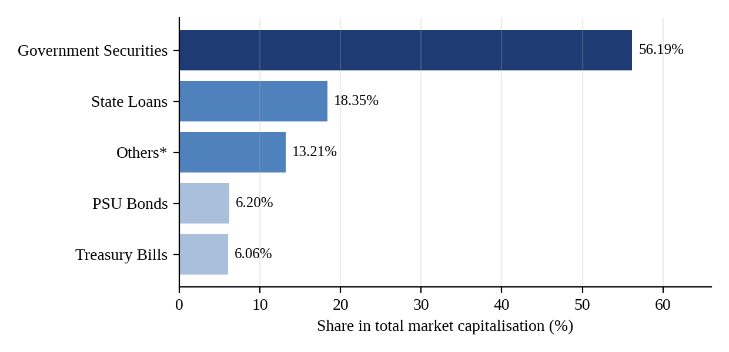
Source: Table 3.1 (FIMMDA-NSE Debt Market Module, Table 2.1)
Interpretation. Government securities alone account for 56.19 per cent of the debt market capitalisation of about Rs. 49.3 lakh crore, and if State loans (18.35 per cent) and treasury bills (6.06 per cent) are added, sovereign and quasi-sovereign paper makes up about 80.6 per cent of the market. PSU bonds, which are treated as surrogates for sovereign paper, add 6.20 per cent. The "others" category, which includes securitised debt and bonds of local bodies, is 13.21 per cent. This shows that the Indian debt market is, in effect, a government securities market, and that private corporate debt listed on the exchange is a small residual. The finding is consistent with the structural challenges listed in Chapter 1, namely the thin corporate bond market and the dominance of government borrowing.
5.3 PARTICIPATION AND CONCENTRATION IN THE WDM
Table 5.1: Participant-wise share of WDM turnover (%)
Participant | 2010-11 | 2011-12 | 2012-13
Foreign banks | 26.78 | 21.57 | 22.10
Indian banks | 13.09 | 15.25 | 16.49
Primary dealers | 4.21 | 4.17 | 3.70
FIs, mutual funds and corporates | 2.41 | 4.51 | 4.35
Trading members | 53.51 | 54.51 | 53.37
Total | 100.00 | 100.01 | 100.01

Source: FIMMDA-NSE Debt Market (Basic) Module, Table 2.4. Totals are as computed from the rounded figures.
Figure 5.2: Participant-wise share of WDM turnover
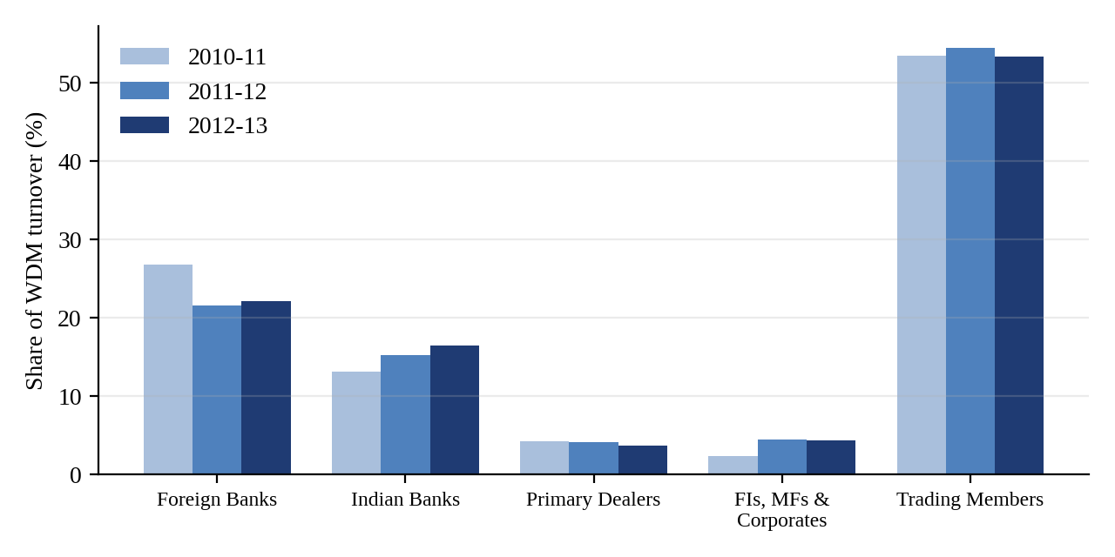
Interpretation. Trading members account for more than half of turnover in each of the three years (53.37 per cent in 2012-13), which reflects the role of brokers and intermediaries in a market where trades are negotiated. Among direct participants, foreign banks are the largest, at 22.10 per cent, but their share fell from 26.78 per cent in 2010-11. Indian banks increased their share from 13.09 to 16.49 per cent over the same period. Primary dealers have a small and slowly declining share of 3.70 per cent, which suggests that much of the market-making activity has shifted to other platforms. Financial institutions, mutual funds and corporates together are under 5 per cent.
Table 5.2 gives the concentration of WDM turnover in the top few participants.
Table 5.2: Concentration of WDM turnover: share of top participants (%) (selected years)
Year | Top 5 | Top 10 | Top 25 | Top 50 | Top 100
1999-00 | 37.11 | 55.57 | 82.12 | 90.73 | 95.28
2001-02 | 51.61 | 68.50 | 88.73 | 94.32 | 97.19
2004-05 | 43.70 | 57.51 | 71.72 | 80.59 | 89.55
2007-08 | 39.65 | 53.31 | 68.35 | 79.64 | 89.55
2009-10 | 24.19 | 35.14 | 53.05 | 65.63 | 77.89
2011-12 | 36.35 | 44.22 | 52.63 | 61.54 | 72.09
2012-13 | 34.02 | 44.36 | 53.04 | 62.32 | 73.29

Source: FIMMDA-NSE Debt Market (Basic) Module. Selected years from the full series.
Figure 5.3: Share of turnover of the top 5, 10 and 25 participants
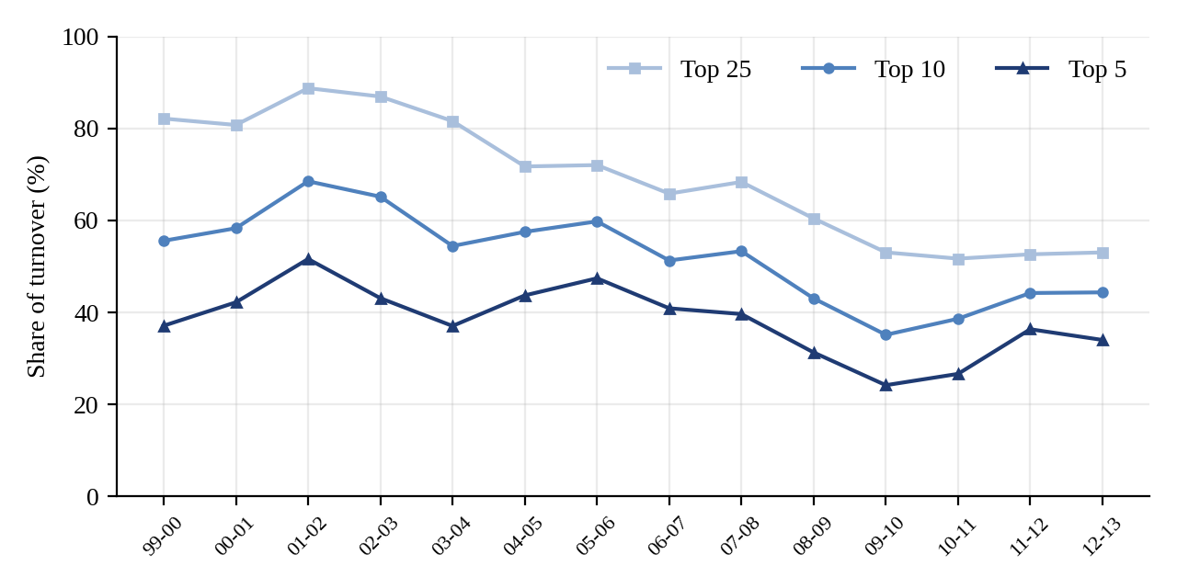
Interpretation. Concentration was highest in 2001-02, when the top five participants accounted for 51.61 per cent of turnover and the top 25 for 88.73 per cent. It then fell steadily, and in 2009-10 the top five accounted for only 24.19 per cent. Concentration rose again in 2011-12 and 2012-13 (34.02 per cent for the top five), but it remains well below the peak. The top 100 participants share fell from 95.28 per cent in 1999-00 to 73.29 per cent in 2012-13. The trend indicates that participation has broadened over the period, although a relatively small number of players still dominate trading.
5.4 CENTRAL GOVERNMENT BORROWING
Table 5.3: Issuance of Government of India dated securities
Year | Weighted avg. yield (%) | Longest tenor issued | Wtd. avg. maturity of issues (yrs) | Wtd. avg. maturity of stock (yrs) | Wtd. avg. coupon of stock (%)
2008-09 | 7.69 | Jun-30 | 13.80 | 10.45 | 8.23
2009-10 | 7.23 | May-15 | 11.16 | 9.82 | 7.89
2010-11 | 7.92 | May-30 | 11.62 | 9.78 | 7.81
2011-12 | 8.52 | Jul-30 | 12.66 | 9.60 | 7.88
2012-13 | 8.36 | May-30 | 13.50 | 9.67 | 7.97

Source: RBI Annual Report, as reproduced in the FIMMDA-NSE Debt Market (Basic) Module, Table VII.3. The column order follows the module table.
Figure 5.4: Weighted average yield of issuance and coupon of outstanding stock
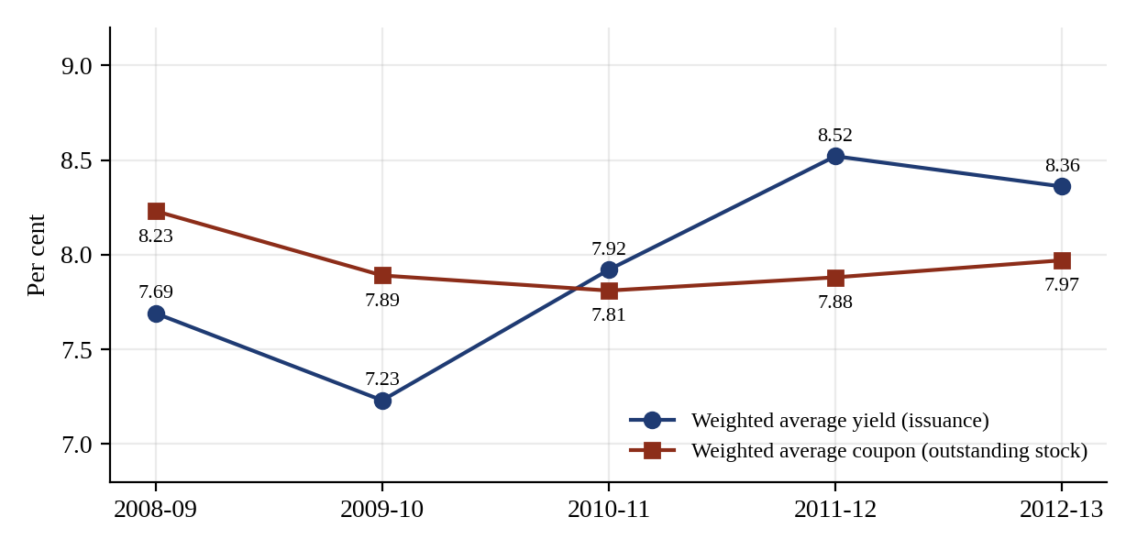
Interpretation. The weighted average yield at which the Government borrowed fell to 7.23 per cent in 2009-10, a year of easy liquidity, and then rose to 8.52 per cent in 2011-12 before easing to 8.36 per cent in 2012-13. The weighted average coupon on the outstanding stock moves much more slowly, from 8.23 per cent to 7.81 per cent and then back to 7.97 per cent, because the stock reflects borrowing from many past years. The gap between the current yield and the stock coupon was 39 basis points in 2012-13 (8.36 less 7.97) and was negative in 2009-10 (7.23 less 7.89), meaning that in that year the Government was borrowing more cheaply than the average rate on its existing debt. The weighted average maturity of new issues rose to 13.5 years in 2012-13, which confirms the Government’s strategy of elongating the maturity profile.
Table 5.4: Maturity pattern of GoI dated securities issued
Residual maturity | 2010-11 (Rs. bn) | % | 2011-12 (Rs. bn) | % | 2012-13 (Rs. bn) | %
Less than 5 years | 110 | 2.52 | 180 | 3.53 | 470 | 8.42
5 - 9.99 years | 1,520 | 34.78 | 2,340 | 45.88 | 1,910 | 34.23
10 - 14.99 years | 1,640 | 37.53 | 1,230 | 24.12 | 1,730 | 31.00
15 - 19.99 years | 540 | 12.36 | 650 | 12.75 | 270 | 4.84
20 years and above | 560 | 12.81 | 700 | 13.73 | 1,200 | 21.51
Total | 4,370 | 100 | 5,100 | 100 | 5,580 | 100

Source: RBI Annual Reports, as given in the FIMMDA-NSE Debt Market (Basic) Module
Figure 5.5: Maturity profile of dated securities issued
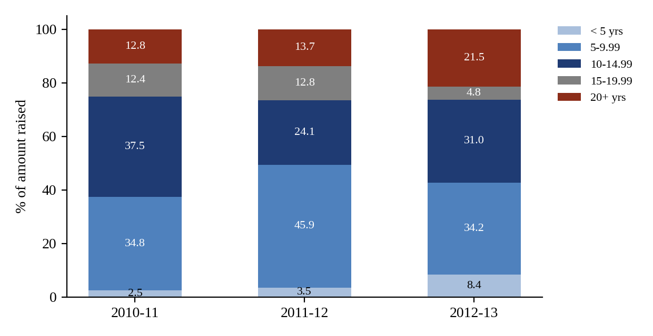
Interpretation. The amount raised increased from Rs. 4,370 billion in 2010-11 to Rs. 5,580 billion in 2012-13, a rise of 27.7 per cent. The 5 to 10 year bucket dominated in 2011-12 (45.88 per cent), but in 2012-13 the share of securities of 20 years and above almost doubled to 21.51 per cent, from 13.73 per cent a year earlier, while issues of less than five years rose to 8.42 per cent. Combined with the lower share of 15 to 20 year paper, the profile shows that the Government was using both ends of the curve in 2012-13, and issuing much longer paper in order to place the larger programme with long-term investors such as insurance and pension funds.
5.5 AUCTION ANALYSIS: DUTCH VERSUS FRENCH
Using the bids in Table 3.3 for the 12.40% 2015 security, the notified amount of Rs. 3,000 crore is filled as follows: bids at prices above the cut-off (Rs. 100 + 650 + 300 + 1,400 = Rs. 2,450 crore) are accepted in full, and the balance of Rs. 550 crore is allotted at the cut-off price of Rs. 111.20. The Government’s proceeds under the two methods are compared below.
Table 5.5: Dutch and French auction outcomes for the 12.40% 2015 auction
Method | Price paid by bidders | Average price for the issue (Rs.) | Total proceeds (Rs. crore, per Rs. 100 face)
Dutch (uniform price) | Every bidder pays Rs. 111.20 | 111.2000 | 3,336.00
French (discriminatory) | Each bidder pays own bid | 111.3576 | 3,340.73
Difference |  | 0.1576 | 4.73

Source: Author’s computation from the bids in Table 3.3
Interpretation. If bidders bid exactly as they would in the other format, the French auction raises Rs. 4.73 crore more for the Government on this issue, because high bidders pay their full bid. In practice, however, the winner’s curse leads bidders in a French auction to shade their bids downwards, so the actual advantage can disappear. With a secondary market price of Rs. 110.65, the loss per bond to the highest bidder in the French auction is Rs. 111.6475 less Rs. 110.65, which is Rs. 0.9975, against a uniform loss of Rs. 0.55 for every bidder in the Dutch auction. This explains why the choice of auction is announced in advance in the auction notification.
5.6 TREASURY BILLS
Table 5.6: Summary of T-bill auctions during 2013-14
Particular | 91-day | 182-day | 364-day
Number of issues | 65 | 39 | 52
Number of bids received (competitive and non-competitive) | 5,473 | 2,730 | 4,581
Amount of competitive bids (Rs. crore) | 13,276 | 6,336 | 8,711
Amount of non-competitive bids (Rs. crore) | 3,147 | 22 | 20
Number of bids accepted | 3,145 | 1,039 | 1,601
Competitive bids accepted (Rs. crore) | 3,837 | 1,984 | 2,659
Non-competitive bids accepted (Rs. crore) | 3,147 | 22 | 20
Total issue (Rs. crore) | 6,984 | 2,006 | 2,679
Cut-off price: minimum / maximum (Rs.) | 97 / 98 | 94 / 96 | 91 / 93

Source: RBI Bulletin, as reproduced in the FIMMDA-NSE Debt Market (Basic) Module, Table 4.2. Figures are as printed in the module.
Table 5.7 shows prices and yields of treasury bills, calculated with the T-bill formulas of Section 3.13.
Table 5.7: Price-yield computations for treasury bills
Bill | Price (Rs.) | Yield | Calculation
182-day at auction price | 95.510 | 9.4280% | (100 − 95.510) × 365 / (95.510 × 182)
91-day at yield 8.50% | 97.9248 | 8.50% | 100 / (1 + 0.085 × 91/365)
182-day at yield 8.60% | 95.8881 | 8.60% | 100 / (1 + 0.086 × 182/365)
364-day at yield 8.75% | 91.9743 | 8.75% | 100 / (1 + 0.0875 × 364/365)

Source: Author’s computation. The first row reproduces the example in the module.
Interpretation. The 91-day bill is the most actively issued: the number of issues is the largest, and the total issued (Rs. 6,984 crore) is far higher than for the other two tenors, partly because of the heavy non-competitive allotments of Rs. 3,147 crore. For a given yield the discount rises with tenor: at about 8.5 per cent, a 91-day bill costs Rs. 97.92, and a 364-day bill costs Rs. 91.97 at 8.75 per cent. Secondary market activity is small, as most buyers hold to maturity.
Figure 5.6: Holding pattern of outstanding T-bills (first and last quarter in the module table)
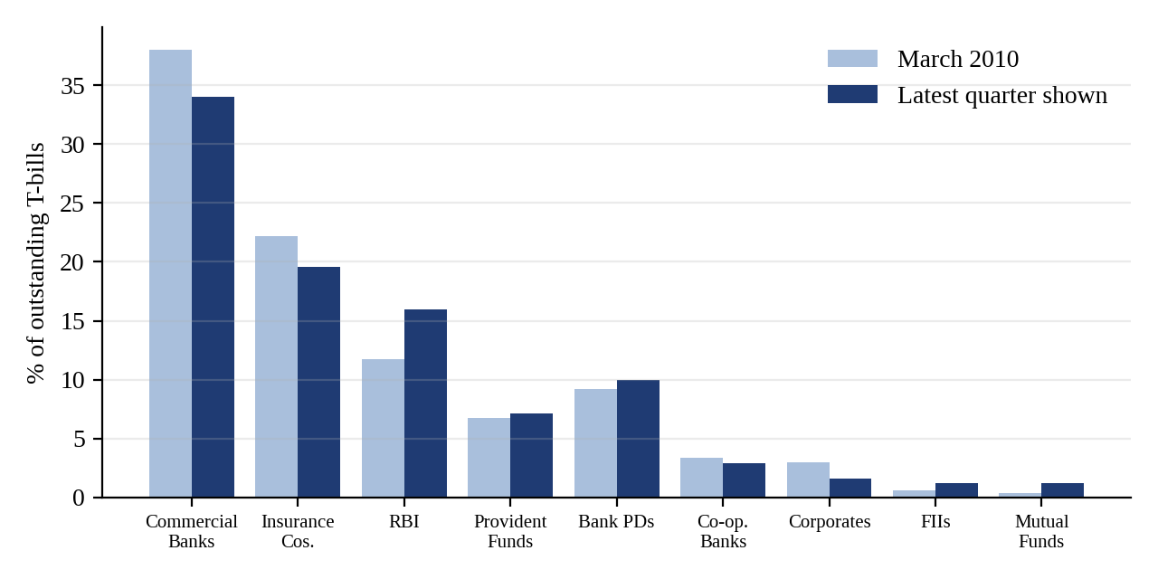
Source: RBI Weekly Statistical Supplement, as given in the module, Table 4.3. "Latest quarter" is the last column of the table.
Interpretation. Commercial banks hold the largest share of outstanding T-bills but their share declined from 38.03 to 33.98 per cent, while the RBI’s share rose from 11.76 to 15.95 per cent. Insurance companies hold around 20 per cent, falling from 22.16 to 19.54 per cent, and provident funds around 7 per cent. Mutual funds and FIIs have small but rising shares (1.20 and 1.24 per cent in the latest quarter, from 0.40 and 0.59 per cent), which shows gradual diversification of the investor base.
5.7 STATE GOVERNMENT FINANCES AND MARKET BORROWING
Table 5.8: Gross fiscal deficit of State Governments and market borrowings (selected years)
Year | Gross fiscal deficit (Rs. crore) | Market borrowings (Rs. crore) | Market borrowings as % of GFD
1999-00 | 90,098 | 12,664 | 14.1
2002-03 | 99,727 | 28,484 | 28.6
2005-06 | 90,084 | 15,305 | 17.0
2008-09 | 1,34,589 | 1,04,041 | 77.3
2010-11 | 1,61,461 | 88,776 | 55.0
2011-12 | 2,07,875 | 1,56,708 | 75.4
2012-13 | 2,15,266 | 1,77,156 | 82.3

Source: RBI Annual Report 2012-13, as given in the module, Table 5.1. Percentages computed from the module data.
Figure 5.7: State gross fiscal deficit and share financed by market borrowings
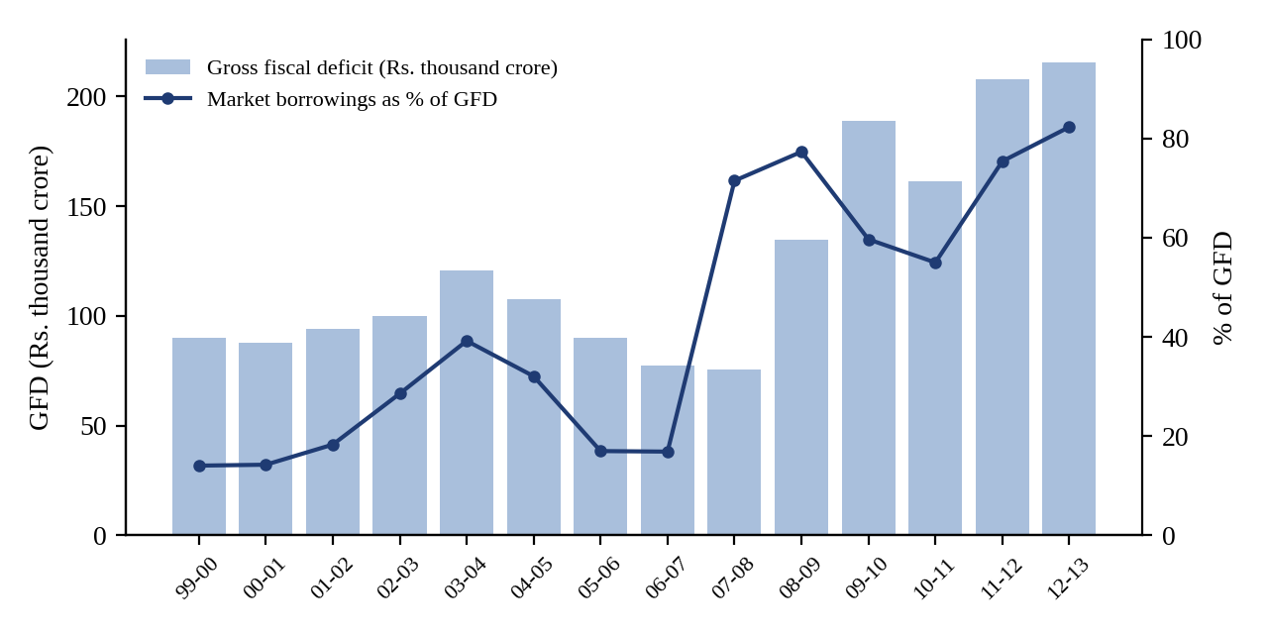
Interpretation. The GFD of the States more than doubled from Rs. 90,098 crore in 1999-00 to Rs. 2,15,266 crore in 2012-13, and the way it is financed has changed completely. In 1999-00 only 14.1 per cent was funded by market borrowings, as States relied on loans from the Centre and on small savings. From 2008-09 market borrowings have funded 55 to 82 per cent of the deficit, and the share reached 82.3 per cent in 2012-13. The shift makes States direct competitors of the Centre for the savings available in the bond market, and explains the widening of State spreads over Central securities to 71 basis points in 2012-13. It also means that the fiscal position of each State is now disciplined, to a degree, by market pricing.
5.8 CALL MONEY MARKET
Figure 5.8: Average call money rate (% per annum)
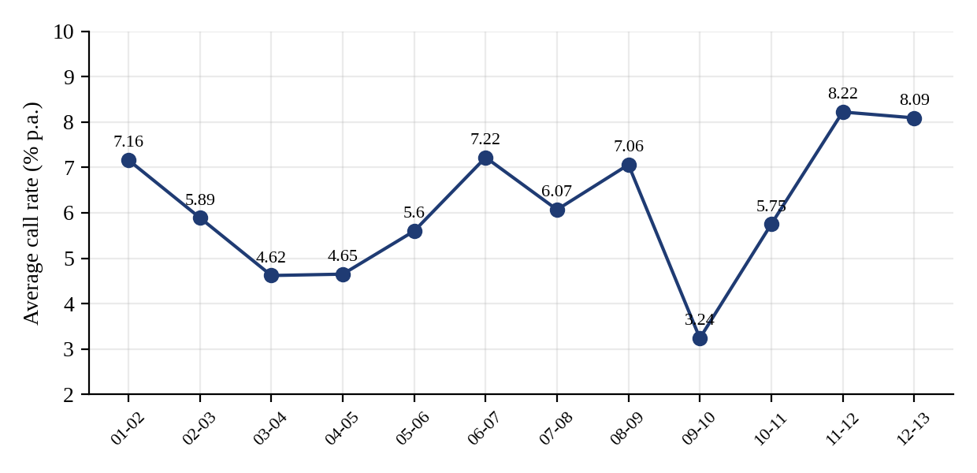
Source: RBI Handbook of Statistics on the Indian Economy 2012-13, as given in the module, Table 6.2 (average column)
Interpretation. The average call rate has been volatile, ranging from 3.24 per cent in 2009-10, when liquidity was abundant, to 8.22 per cent in 2011-12 and 8.09 per cent in 2012-13, when liquidity was tight. The call rate is therefore a sensitive indicator of liquidity conditions, and it tends to move between the repo and reverse repo rate in normal times and to rise sharply when liquidity is scarce. The extreme daily maximum values shown in the module for individual years are much higher than the annual averages, which indicates that spikes are short-lived. The pure inter-bank character of the market, achieved after the exit of non-banks in 2005, has not removed this volatility.
5.9 COMMERCIAL PAPER
Figure 5.9: Outstanding commercial paper
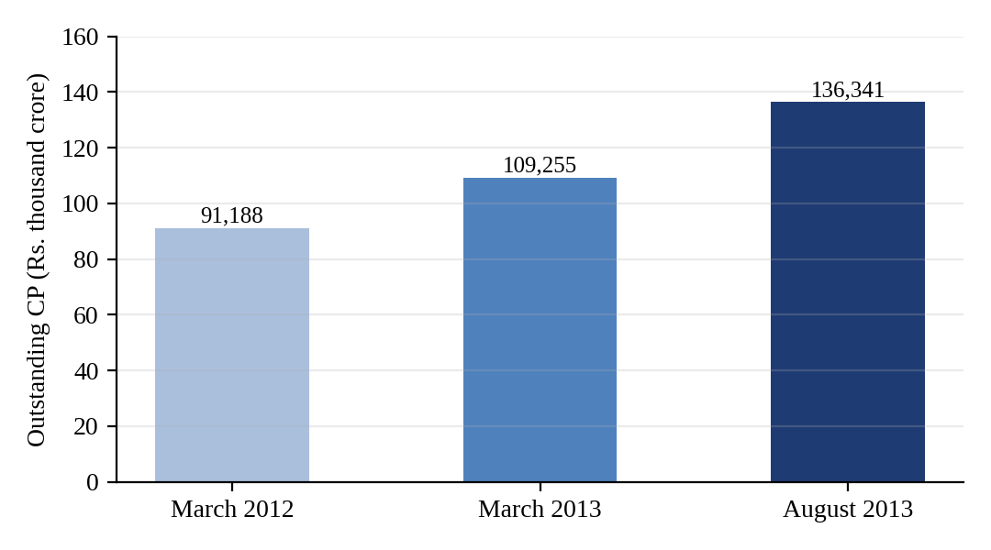
Source: RBI Handbook of Statistics on the Indian Economy 2012-13, as given in the module, Table 8.1
Interpretation. Outstanding CP rose from Rs. 91,188 crore in March 2012 to Rs. 1,09,255 crore in March 2013 (an increase of 19.8 per cent) and to Rs. 1,36,341 crore by August 2013. The discount rate range narrowed and shifted down: from 9.75 - 15.25 per cent in March 2012 to 8.05 - 13.42 per cent in March 2013 and 7.82 - 12.84 per cent in August 2013. The wide band between the lowest and highest rates reflects the difference in credit quality between top-rated and lower-rated issuers.
Table 5.9: Stamp duty on commercial paper (per cent), effective 1 March 2004
Maturity | Banks: past | Banks: present | Non-banks: past | Non-banks: present
Up to 3 months | 0.050 | 0.012 | 0.125 | 0.060
3 to 6 months | 0.100 | 0.024 | 0.250 | 0.120
6 to 9 months | 0.150 | 0.036 | 0.375 | 0.180
9 to 12 months | 0.200 | 0.050 | 0.500 | 0.250
Above 12 months | 0.400 | 0.100 | 1.000 | 0.500

Source: RBI, as given in the module, Table 8.2
Interpretation. The reduction in stamp duty from March 2004 was substantial: for a CP of up to three months the duty for banks fell from 0.05 to 0.012 per cent, and for non-banks from 0.125 to 0.06 per cent. The duty rises with maturity, and banks pay less than non-banks at every maturity. The module also notes that no stamp duty is applicable on CP issues in the USA, UK and France, which indicates that the cost can be a barrier to market development.
5.10 BOND VALUATION
5.10.1 Valuation from first principles
The value of a bond is the present value of its expected cash flows, discounted at the required yield. For a plain vanilla bond the cash flows are the coupons and the redemption of principal, and for a bond paying semi-annual coupons the price is
P = Σ [ C/2 / (1 + y/2)^t ] + F / (1 + y/2)^n
where C is the annual coupon, y the required yield, F the redemption value and n the number of half-years to maturity. The module values a Central Government 11.75 per cent bond with 8 years to redemption at a required rate of 12 per cent. The semi-annual coupon is Rs. 5.875 and the semi-annual discount rate is 6 per cent.
Table 5.10: Value of an 11.75% bond with 8 years to redemption at a required yield of 12%
Half-year | Cash flow (Rs.) | PV at 6% (Rs.)
1 | 5.875 | 5.542
2 | 5.875 | 5.229
3 | 5.875 | 4.933
4 | 5.875 | 4.654
5 | 5.875 | 4.390
6 | 5.875 | 4.142
7 | 5.875 | 3.907
8 | 5.875 | 3.686
9 | 5.875 | 3.477
10 | 5.875 | 3.281
11 | 5.875 | 3.095
12 | 5.875 | 2.920
13 | 5.875 | 2.754
14 | 5.875 | 2.599
15 | 5.875 | 2.451
16 | 105.875 | 41.677
Value |  | 98.737

Source: Author’s recomputation of Table 13.1 of the module. The value of Rs. 98.737 matches the module exactly.
Interpretation. Because the required yield (12 per cent) is higher than the coupon (11.75 per cent), the bond is valued below par, at Rs. 98.737. The module derives three rules from the valuation equation: (a) if the required yield equals the coupon, the bond sells at par; (b) if the required yield is lower than the coupon, the bond sells at a premium; (c) if the required yield is higher than the coupon, the bond sells at a discount.
5.10.2 Price-yield relationship
Table 5.11: Price of a 10% coupon, 10-year bond at different yields
Required yield | Price of a 10% 10-year bond (Rs.) | Status
6% | 129.755 | Premium
7% | 121.319 | Premium
8% | 113.590 | Premium
9% | 106.504 | Premium
10% | 100.000 | Par
11% | 94.025 | Discount
12% | 88.530 | Discount
13% | 83.472 | Discount
14% | 78.812 | Discount

Source: Author’s computation
Figure 5.10: Price-yield relationship for bonds of different coupon and maturity
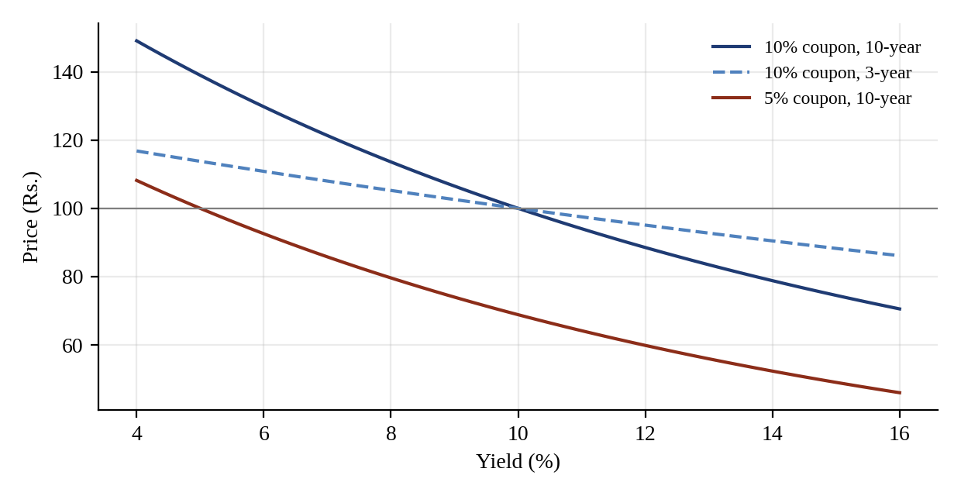
Interpretation. The price falls as yield rises, but the relationship is not a straight line. For the 10 per cent 10-year bond, a one percentage point fall in yield from 10 to 9 per cent raises the price by Rs. 6.50, while a one point rise to 11 per cent lowers it by Rs. 5.98. The curve is convex, so gains from a fall in yield exceed losses from an equal rise. The figure also shows that the 10-year bond is far more sensitive than the 3-year bond, and that a low-coupon bond (5 per cent) is more sensitive than a high-coupon bond of the same maturity. These observations lead to the concept of duration in Section 5.12.
5.10.3 Time path of a bond
Even if the required yield does not change, the value of a bond changes over time and converges to the redemption value as maturity approaches. This is the time path of the bond.
Table 5.12: Price of a 10% bond as it approaches maturity (Rs.)
Required yield | 10 yrs | 8 yrs | 6 yrs | 4 yrs | 2 yrs | 1 yr
8% | 113.59 | 111.65 | 109.39 | 106.73 | 103.63 | 101.89
10% | 100.00 | 100.00 | 100.00 | 100.00 | 100.00 | 100.00
12% | 88.53 | 89.89 | 91.62 | 93.79 | 96.53 | 98.17

Source: Author’s computation, for time left to maturity shown in the column heading
Figure 5.11: Time path of a 10% coupon bond
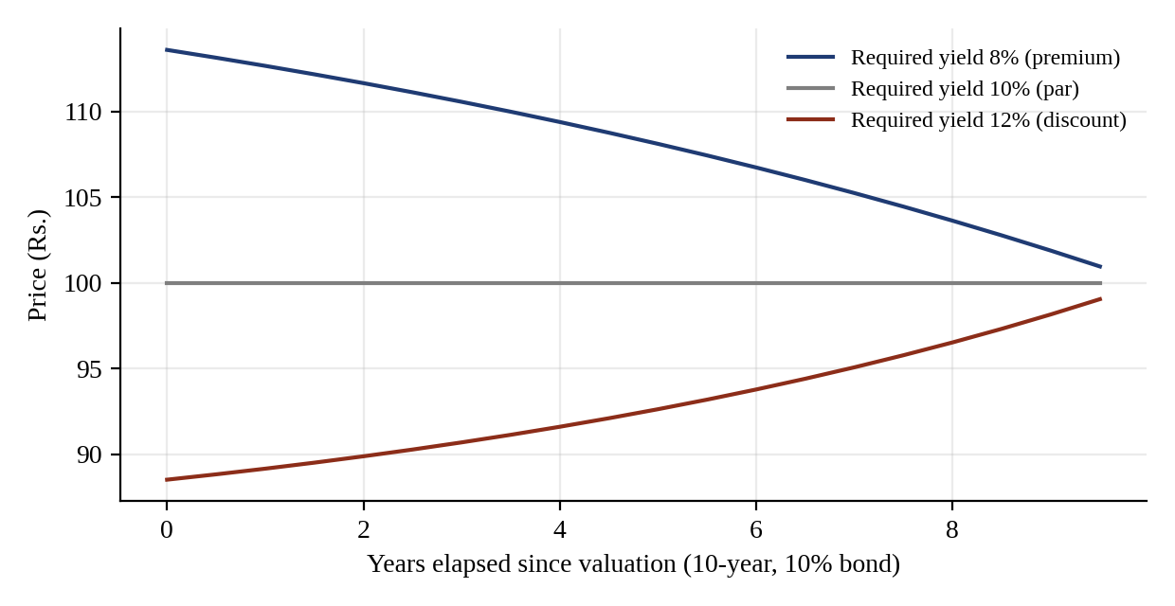
Interpretation. A premium bond (required yield 8 per cent) falls from Rs. 113.59 to Rs. 101.89 with one year left, and a discount bond (12 per cent) rises from Rs. 88.53 to Rs. 98.17. The module shows the same effect for the 7.40% 2012 bond, whose price at a required yield of 6 per cent declines from Rs. 109.0019 on 29 January 2004 to Rs. 103.141 on 21 November 2009. A holder of a premium bond therefore has a built-in capital loss each year, and a holder of a discount bond has a built-in capital gain, which should be considered together with the coupon when measuring return.
5.10.4 Day count and accrued interest
When a bond is traded between coupon dates the buyer pays the seller the interest accrued since the last coupon. Accrued interest = Coupon payment × (days from last coupon / days in coupon period), computed on the 30/360 basis in the Indian government securities market. Consider an illustrative 8% semi-annual bond with coupon dates 15 January and 15 July, settled on 12 March.
Table 5.13: Accrued interest illustration
Item | Value
Semi-annual coupon | Rs. 4.00
Days from last coupon (15 Jan to 12 Mar, 30/360) | 57 days
Days in coupon period (30/360) | 180 days
Accrued interest | 4.00 × 57/180 = Rs. 1.2667
If the clean price is Rs. 101.50 | Dirty (gross) price = Rs. 102.7667

Source: Author’s illustration, using the method in the module
The module defines the gross price as the net (clean) price plus accrued interest. Quoted prices in the market are clean prices; the buyer actually pays the gross price. This convention keeps the quoted price from jumping at each coupon date.
5.10.5 Measures of yield
- Current yield = annual coupon / market price. For a 12.5% bond selling at Rs. 104.50 it is 11.96 per cent. It ignores the time value of money and the gain or loss on redemption, so it is no longer a standard yield measure.
- Yield to maturity (YTM) is the discount rate that equates the price to the present value of all cash flows. The module illustrates a bond with 18 semi-annual coupons of Rs. 5.995 (an 11.99% bond with 9 years to run) with a semi-annual YTM of 5.29 per cent, which is a YTM of 10.58 per cent. Recomputing, the price of this bond at 10.58% is Rs. 108.06, and solving back for the yield from this price returns 10.58%. YTM assumes that coupons are reinvested at the YTM and the bond is held to maturity.
- Bond equivalent yield: yields in the market are generally quoted on a bond equivalent basis, in which the semi-annual yield is doubled. With an effective annual yield of 12.095%, the semi-annual yield is (1.12095)^0.5 − 1 = 5.875 per cent, so the bond equivalent yield is 11.75 per cent.
- Weighted yield: when a bond trades at different prices on a day, the yield for the day is the average of the trade yields weighted by value of trades. In the module’s example for CG 11.3% 2010 the weighted yield is 10.34 per cent. The YTM of a portfolio is not the weighted average of the YTMs of its bonds but the discount rate that equates the total value to the present value of the combined cash flows.
- Realised yield (total return) depends on coupon income, reinvestment income and capital gain or loss. A rise in rates raises reinvestment income and reduces capital gains, and a fall does the opposite, and longer holding periods raise the coupon component of the return.
5.11 YIELD CURVE AND TERM STRUCTURE
5.11.1 The yield curve
The yield curve shows the relationship between yield and term to maturity. The module provides prices and YTMs of twelve Central Government bonds, which are used below to construct the curve.
Table 5.14: Central Government bonds used to construct the yield curve
Bond | Coupon (%) | Term (years) | Price (Rs.) | YTM (%)
CG2001 | 11.75 | 0.41 | 101.00 | 9.09
CG2002 | 11.15 | 0.78 | 102.75 | 7.41
CG2003 | 11.10 | 2.02 | 103.52 | 9.15
CG2004 | 12.50 | 2.98 | 108.31 | 9.25
CG2005 | 11.19 | 4.37 | 106.19 | 9.42
CG2006 | 11.68 | 5.03 | 107.58 | 9.74
CG2007 | 11.90 | 6.16 | 109.31 | 9.84
CG2008 | 11.40 | 7.42 | 107.60 | 9.92
CG2009 | 11.99 | 8.02 | 109.18 | 10.28
CG2010 | 11.30 | 9.33 | 106.60 | 10.18
CG2011 | 12.32 | 9.83 | 110.97 | 10.40
CG2013 | 12.40 | 12.39 | 111.20 | 10.74

Source: FIMMDA-NSE Debt Market (Basic) Module, Chapter 14. The coupon, term, price and YTM values are as printed in the module.
Figure 5.12: Yield curve from the YTMs of Central Government bonds
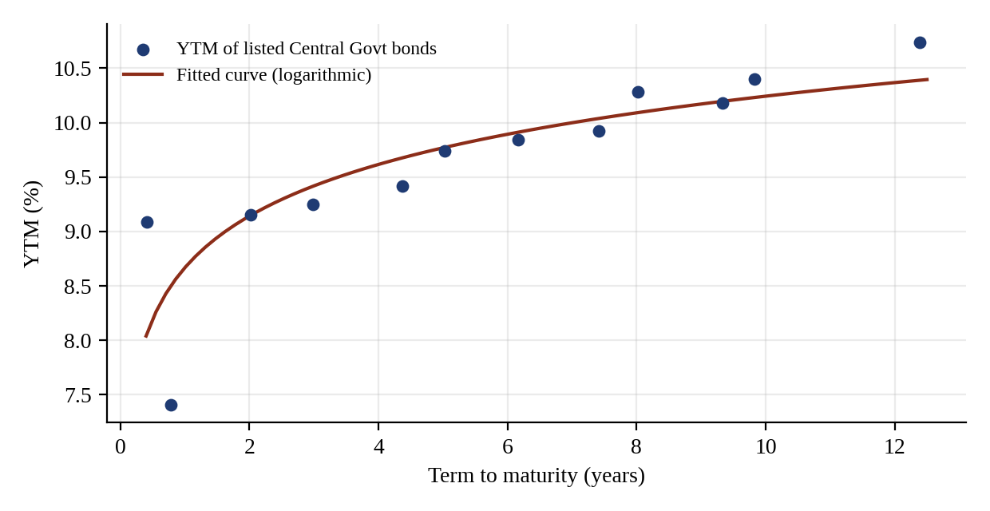
Interpretation. Yields rise with term, from about 9 per cent for the short bonds to 10.74 per cent for the 12.39-year bond, so the curve is upward sloping. A logarithmic curve fitted to the twelve points has the form YTM = 8.67 + 0.685 × ln(term), and it gives a yield of about 10.2 per cent at 10 years. The CG2002 bond, at 7.41 per cent, lies well below the curve, which shows that individual bonds can deviate from the fitted curve because of liquidity and coupon effects, and that a smooth curve is needed to value bonds that do not trade. The module fits a parametric equation with estimated coefficients in the same way, so that a yield can be read off for any term.
5.11.2 Zero coupon yield curve and bootstrapping
The YTM of a coupon bond assumes reinvestment at the YTM, so YTM curves are not "pure" rates. The zero coupon yield curve (ZCYC) is made up of spot rates, each applicable to a single cash flow at a given tenor, and every coupon bond can be seen as a bundle of zero coupon bonds. Where zero coupon bonds do not trade, the spot rates are derived from coupon bond prices by bootstrapping: starting from the shortest maturity, the spot rate for each cash flow is solved from the bond price after substituting the spot rates already found for the earlier cash flows.
As an illustration, assume four bonds trading at par, with semi-annual coupons: a six-month bill at 7.00 per cent, a one-year bond at 7.40 per cent, a 1.5-year bond at 7.60 per cent and a two-year bond at 7.90 per cent. For a par bond, 100 = Σ (c/2) × DF(t) + 100 × DF(n), so the discount factor for the last period is DF(n) = (100 − Σ (c/2) DF(t)) / (100 + c/2).
Table 5.15: Bootstrapping zero rates from par bonds (illustrative)
Maturity | Par coupon (%) | Discount factor | Zero rate, bond equivalent (%)
0.5 year | 7.00 | 0.96618 | 7.0000
1.0 year | 7.40 | 0.92985 | 7.4074
1.5 years | 7.60 | 0.89398 | 7.6128
2.0 years | 7.90 | 0.85598 | 7.9283

Source: Author’s illustrative computation, applying the method in Chapter 14 of the module
Figure 5.13: Par yields and bootstrapped zero rates
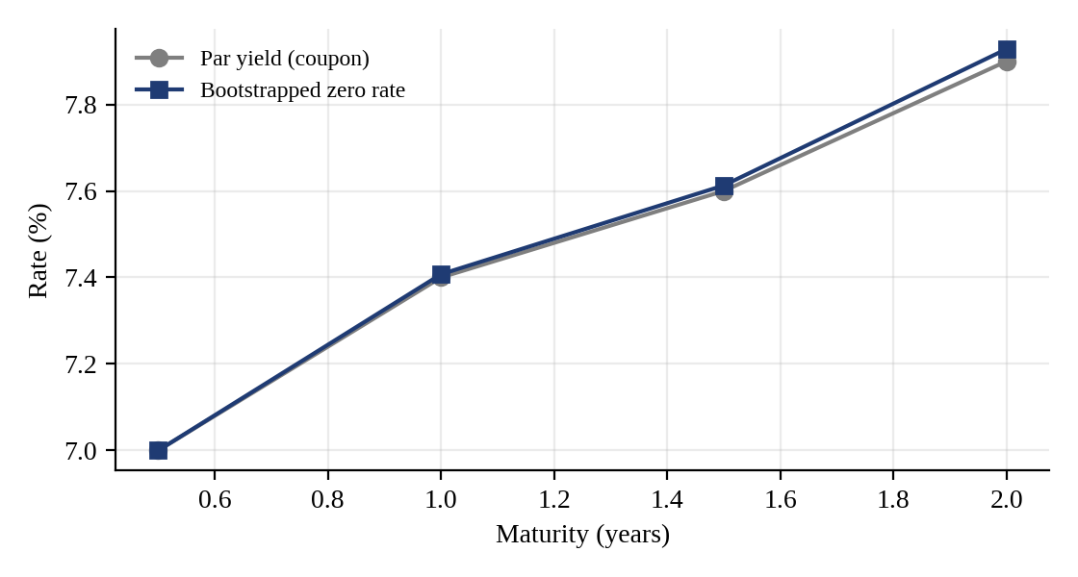
Interpretation. In an upward sloping curve the zero rates lie above the par yields, and the gap widens with maturity: at two years the zero rate is 7.93 per cent against a par yield of 7.90 per cent. The implied forward rate for the six months starting six months from now follows from the spot rates: (1.037037)^2 / 1.035 − 1 = 3.908 per cent per half-year, or 7.82 per cent a year. Forward rates above the spot rates are what an upward sloping curve implies.
5.11.3 Theories of the term structure
Table 5.16: Interpretation of yield curve shapes under alternative theories
Curve shape | Pure expectations | Liquidity preference | Preferred habitat
Upward sloping | Short rates expected to rise | Positive and rising liquidity premia | Excess of supply over demand in longer maturities
Downward sloping | Short rates expected to fall | Negative premia, rising with term | Excess of supply over demand in shorter maturities
Flat | Short rates not expected to change | No liquidity premium | Supply and demand matched at all maturities
Humped | Rates expected to rise first, then fall | Premia positive up to a term, then negative | Excess of supply in intermediate maturities

Source: Adapted from the summary in Chapter 14 of the module
The pure expectations hypothesis, pioneered by Irving Fisher in 1896, explains the curve as a series of expected forward rates, so that the long-term rate is the geometric mean of expected short-term rates. The liquidity preference hypothesis adds a risk premium, because investors prefer short-term bonds, whose prices are less risky. The preferred habitat theory holds that investors and borrowers have preferred maturities and need a premium to move away from them, so the curve reflects supply and demand at different tenors.
5.12 DURATION AND INTEREST RATE RISK
5.12.1 Macaulay duration
Duration is the weighted average time to the receipt of the cash flows of a bond, where the weights are the present values of the cash flows. It was introduced by Frederick Macaulay in 1938. For a bond paying k coupons per year,
Duration (years) = [ Σ t × PV(CF_t) / Σ PV(CF_t) ] / k
Table 5.17: Duration of an 11% 5-year bond at a YTM of 9% (semi-annual)
Period | Cash flow (Rs.) | PV at 4.5% (Rs.) | t × PV | Weight | Weighted period
1 | 5.5 | 5.26 | 5.263 | 0.049 | 0.049
2 | 5.5 | 5.04 | 10.073 | 0.047 | 0.093
3 | 5.5 | 4.82 | 14.459 | 0.045 | 0.134
4 | 5.5 | 4.61 | 18.448 | 0.043 | 0.171
5 | 5.5 | 4.41 | 22.067 | 0.041 | 0.204
6 | 5.5 | 4.22 | 25.341 | 0.039 | 0.235
7 | 5.5 | 4.04 | 28.291 | 0.037 | 0.262
8 | 5.5 | 3.87 | 30.940 | 0.036 | 0.287
9 | 5.5 | 3.70 | 33.309 | 0.034 | 0.309
10 | 105.5 | 67.93 | 679.344 | 0.630 | 6.295
Total |  | 107.91 | 867.535 | 1.000 | 8.04

Source: Author’s recomputation of Table 15.2 of the module. Price Rs. 107.91 and duration 8.04 half-years (4.02 years) match the module.
Interpretation. The bond has a five-year maturity but a duration of only 4.02 years, because the investor receives coupons along the way; the last cash flow carries 63 per cent of the present value, and the remaining 37 per cent is spread over the earlier coupons. For a zero coupon bond duration equals maturity, as there is a single cash flow.
5.12.2 Determinants of duration
Table 5.18: Macaulay duration (years) at a YTM of 9%
Coupon | 2 years | 5 years | 10 years | 20 years
0% (zero) | 2.00 | 5.00 | 10.00 | 20.00
6% | 1.91 | 4.35 | 7.35 | 10.44
8% | 1.89 | 4.20 | 6.95 | 9.83
10% | 1.86 | 4.07 | 6.66 | 9.43
12% | 1.84 | 3.97 | 6.43 | 9.15

Source: Author’s computation, semi-annual coupons
Figure 5.14: Duration of bonds with different coupons and maturities at a 9% yield
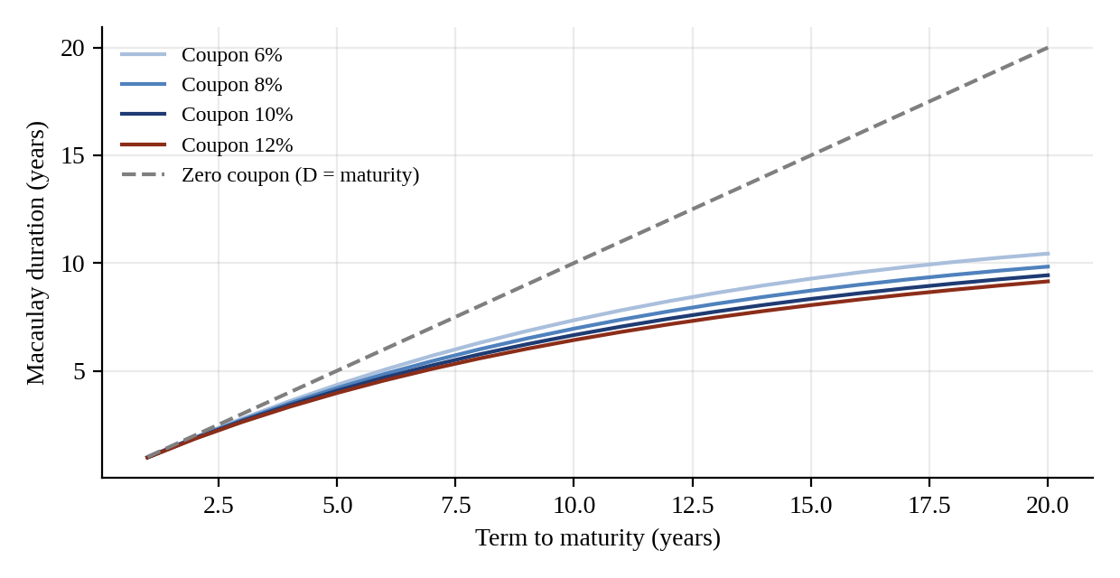
Interpretation. Table 5.18 and Figure 5.14 confirm the three relationships in the module. First, duration increases with term to maturity (a 6% bond has a duration of 1.91 years at 2 years but 10.44 years at 20 years). Second, duration is inversely related to the coupon rate: for a 10-year bond, duration falls from 7.35 years at a 6% coupon to 6.43 years at a 12% coupon, because a higher coupon brings cash flows earlier. Third, duration is inversely related to yield: the 11% 5-year bond has a duration of 4.06 years at a yield of 7 per cent, 4.02 years at 9 per cent and 3.98 years at 11 per cent. Duration grows more slowly than maturity for long bonds: for a 20-year bond it is only about half of the maturity (between 9.15 and 10.44 years at the coupons shown).
5.12.3 Modified duration and price sensitivity
Duration also measures the sensitivity of price to yield. The percentage change in price for a small change in yield is approximately − Modified duration × Δy, where modified duration = Macaulay duration / (1 + y/k). Rupee duration is modified duration multiplied by the price divided by 100 (the change in price for a 100 basis point change in yield), and PV01 (price value of a basis point) is the rupee duration divided by 100, which is the change in price for one basis point.
For the 10% 10-year bond priced at par (yield 10 per cent), the Macaulay duration is 6.543 years, modified duration is 6.231 years, rupee duration is Rs. 6.23 and the PV01 is Rs. 0.0623. Table 5.19 compares the price change estimated with duration against the exact change.
Table 5.19: Exact versus duration-based price change, 10% 10-year bond
Change in yield | Exact change in price (Rs.) | Duration estimate (Rs.) | Estimation error (Rs.)
+1% | -5.98 | -6.23 | -0.26
-1% | 6.50 | 6.23 | -0.27
+2% | -11.47 | -12.46 | -0.99
-2% | 13.59 | 12.46 | -1.13

Source: Author’s computation
Interpretation. The duration estimate is very close for a one percentage point change, with an error of about 26 paise. For a two percentage point change the error rises to about one rupee. The estimate is always below the true price: duration overstates the price fall when yields rise (estimate of Rs. 6.23 against the actual Rs. 5.98) and understates the price gain when yields fall (Rs. 6.23 against Rs. 6.50). This is because of the convexity of the price-yield curve seen in Figure 5.10, so duration is reliable for small changes in yield, and less so for large moves.
Table 5.20: Modified and rupee duration of Central Government bonds
Bond | Price (Rs.) | Modified duration (yrs) | Rupee duration (Rs.)
CG2001 | 101.00 | 0.39 | 0.39
CG2002 | 102.75 | 0.73 | 0.74
CG2003 | 103.52 | 1.70 | 1.76
CG2004 | 108.31 | 2.48 | 2.68
CG2005 | 106.19 | 3.39 | 3.60
CG2006 | 107.58 | 3.62 | 3.89
CG2007 | 109.31 | 4.25 | 4.64
CG2008 | 107.60 | 4.99 | 5.37
CG2009 | 109.18 | 4.96 | 5.42
CG2010 | 106.60 | 5.72 | 6.09
CG2011 | 110.97 | 5.75 | 6.38
CG2013 | 111.20 | 6.50 | 7.23

Source: FIMMDA-NSE Debt Market (Basic) Module, Table 15.6
Figure 5.15: Modified duration and rupee duration of Central Government bonds
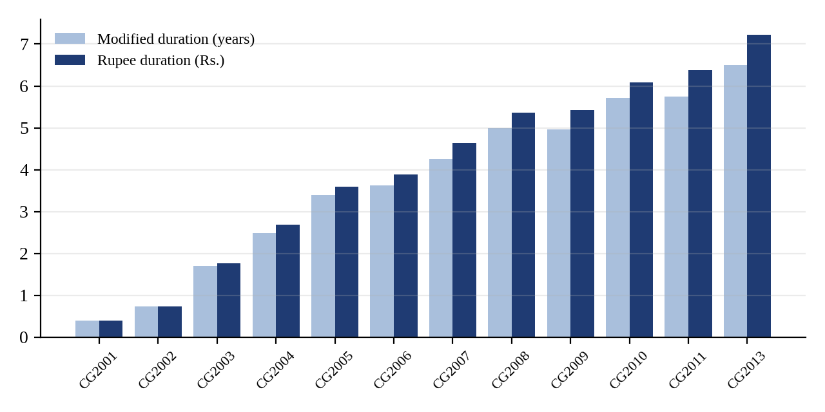
Interpretation. Modified duration rises from 0.39 years for the shortest bond to 6.50 years for the longest, so the longest bond is about 17 times more sensitive to yield than the shortest in percentage terms. The CG2009 bond (11.99% coupon, 8.02 years) has a slightly lower duration (4.96) than CG2008 (4.99), although it has a longer maturity, because its coupon is higher; this is the inverse relationship between coupon and duration. Rupee duration is higher than modified duration for bonds trading above par, since it scales by price: for CG2013, a rise in yield of 100 basis points reduces its price by about Rs. 7.23, and its PV01 is about Rs. 0.0723.
5.12.4 Portfolio duration
The duration of a portfolio is the weighted average of the durations of its bonds, using market values as weights. This is the main reason why duration is the preferred tool of portfolio managers. Consider an illustrative portfolio of three bonds, all at a yield of 9 per cent.
Table 5.21: Portfolio modified duration (illustrative, equal face value in each bond)
Bond | Price (Rs.) | Modified duration (yrs) | Market value weight | Contribution (yrs)
8% bond, 3 years | 97.42 | 2.604 | 0.3004 | 0.782
10% bond, 7 years | 105.11 | 5.021 | 0.3241 | 1.627
12% bond, 12 years | 121.74 | 6.845 | 0.3754 | 2.570
Portfolio (equal face value) |  |  | 1.0000 | 4.980

Source: Author’s computation
Interpretation. The portfolio has a modified duration of about 4.98 years. A parallel rise in yields of 100 basis points would reduce the value of the portfolio by roughly 4.98 per cent, and a fall of 100 basis points would increase it by about the same amount. A manager who expects interest rates to rise would shorten the portfolio duration, for example by replacing the 12-year bond by shorter bonds, and a manager who expects rates to fall would lengthen it. For hedging, the PV01 of the portfolio (modified duration × market value × 0.0001) gives the rupee exposure per basis point.
5.13 SUMMARY OF FINDINGS
Table 5.22: Summary of findings
Area | Finding
Market structure | Government securities are 56.19% of market capitalisation; sovereign and quasi-sovereign paper (with State loans and T-bills) is about 80.6%
Participation | Trading members account for 53.37% of WDM turnover; concentration has fallen from the 2001-02 peak
Government borrowing | Amount raised rose 27.7% from 2010-11 to 2012-13; the share of 20-year and longer paper rose to 21.51% in 2012-13
T-bills | 91-day bill most actively issued; banks and the RBI hold the largest shares
State finances | Market borrowings financed 82.3% of the States’ gross fiscal deficit in 2012-13, against 14.1% in 1999-00
Money market | Call rates averaged 8.09% in 2012-13; CP outstanding rose to Rs. 1,36,341 crore by August 2013
Valuation | Price moves inversely and convexly with yield; premium and discount bonds converge to par
Yield curve | Upward sloping; curve of twelve CG bonds rises from about 9% to 10.74%
Duration | Duration rises with maturity and falls with coupon and yield; the duration estimate is accurate for small changes in yield

Source: Author’s analysis

CHAPTER 6
CONCLUSION AND SUGGESTIONS
6.1 CONCLUSION
Structure of the market
- The Indian debt market is dominated by the government. Government securities are 56.19 per cent of the market capitalisation of debt on the NSE, and with State loans and T-bills, sovereign paper is about four-fifths of the market. Corporate debt remains a small segment, and its growth has been hindered by weak infrastructure, thin liquidity, a narrow investor base and costs of issuance.
- The market is a wholesale, institutional market. Banks, driven by the SLR requirement, insurance companies, provident funds, mutual funds and primary dealers hold most of the securities, and trading members account for over half of the WDM turnover. Concentration of turnover has declined since 2001-02, which indicates broader participation.
- A strong infrastructure has been built since the 1990s: auction-based issuance, the primary dealer system, SGL and CSGL accounts, NDS and NDS-OM, CCIL as a central counterparty with guaranteed settlement, RTGS, the LAF and the Retail Debt Market. These have made trading and settlement faster, safer and more transparent.
Government borrowing and money markets
- The Central Government meets most of its fiscal deficit from the market, and is lengthening the maturity of its borrowing: the weighted average maturity of issues was 13.5 years in 2012-13, and 21.51 per cent of the amount raised was in securities of 20 years and above.
- States have become major borrowers. Market borrowings financed 82.3 per cent of the States’ gross fiscal deficit in 2012-13, up from 14.1 per cent in 1999-00, and the spread of State loans over Central securities widened to 71 basis points.
- The call market, now a pure inter-bank market, is sensitive to liquidity conditions, with the average rate ranging from 3.24 to 8.22 per cent over the last four years of the series. The RBI’s LAF and the repo corridor provide the anchor for short-term rates.
- Commercial paper outstanding rose by about 20 per cent in the year to March 2013, and the cost of issuing CP fell after the reduction in stamp duty and rationalisation of the guidelines.
Valuation, yield curve and duration
- Bond prices and yields are inversely related, and the relationship is convex. A bond sells at par when the required yield equals the coupon, at a premium when the yield is lower and at a discount when the yield is higher, and its price converges to par as maturity approaches.
- The yield curve of the Central Government bonds is upward sloping, with yields rising from about 9 per cent to 10.74 per cent over a term of 12 years. Zero coupon rates can be derived from coupon bonds by bootstrapping, and the term structure can be interpreted through the expectations, liquidity preference and preferred habitat theories.
- Duration is the key measure of interest rate risk. It rises with maturity, and falls with coupon and yield. Modified duration, rupee duration and PV01 convert it into an estimate of price change, which is accurate for small yield changes but understates gains and overstates losses for larger changes because of convexity.
Overall, the study shows that the Indian debt market has developed from a controlled, segmented and illiquid market into a market with free pricing, electronic trading, guaranteed settlement and a well-defined regulatory framework. It remains, however, a government-dominated and institutional market, and its further development depends on deepening the corporate bond market, widening the investor base and improving secondary market liquidity.
6.2 SUGGESTIONS
- Deepen the corporate bond market by simplifying the issuance process, reducing costs such as stamp duty, improving credit assessment and ensuring that trades are reported and settled on a transparent platform.
- Widen the investor base by encouraging retail participation through the Retail Debt Market, non-competitive bidding and debt mutual funds, and by making information on debt instruments easy to access.
- Improve secondary market liquidity in government securities by making greater use of the anonymous NDS-OM platform, permitting short selling and when-issued trading, and encouraging market making by primary dealers.
- Develop strips and securitisation under the legal framework of the Government Securities Act, 2006 and the SARFAESI Act so that investors have access to zero coupon instruments and to asset-backed securities.
- Strengthen risk management by using duration, PV01 and stress testing of yield changes in the treasury operations of banks and institutions, because portfolios are exposed to large mark-to-market risk when yields rise.
- Improve data availability by consolidating information on privately placed debt, which at present is difficult to aggregate because of the divided regulatory responsibility between the RBI and SEBI.
6.3 LEARNING OUTCOMES
The project gave the author a structured understanding of the Indian debt market, a working command of the formulas of bond valuation and duration, and the habit of checking each numerical result against an independent calculation. It also built the foundation for the NCFM certification in the debt market, and for further study of interest rate derivatives and treasury management.

CHAPTER 7
LIMITATIONS OF THE STUDY
- Dependence on a single source. The study is based mainly on one study module. Although the module draws its data from the RBI, SEBI, NSE and CCIL, the statistics have not been verified against the original publications, and some tables in the module are printed in a condensed form.
- Period of the data. The data relates mainly to the period up to 2012-13 and the first part of 2013-14. The debt market has changed since then, with new regulations, new instruments and revised limits, and the figures should not be treated as current.
- No primary data. The study does not include interviews or surveys of market participants such as dealers, treasury managers or investors, and therefore does not capture the practical perspective of the market.
- Illustrative examples. Several numerical examples, such as the accrued interest, bootstrapping and portfolio duration illustrations, are hypothetical and are meant to explain the method. They do not represent actual trades or market rates.
- Simplifying assumptions. The valuation and duration calculations assume flat discount rates, no default, no embedded options and semi-annual coupons. The duration measure is accurate for small, parallel shifts in yields only.
- Scope. The report does not cover fixed income derivatives such as interest rate swaps and forward rate agreements, equity and foreign exchange markets, or the taxation of debt instruments.
- Subjectivity of interpretation. The conclusions drawn from the data reflect the judgement of the author, and others may reach different views on the same facts.

CHAPTER 8
BIBLIOGRAPHY
8.1 BOOKS AND STUDY MATERIAL
- FIMMDA-NSE Debt Market (Basic) Module, NSE Academy Limited, National Stock Exchange of India Limited, Mumbai.
- NSE Certification in Financial Markets (NCFM) module list and examination details, NSE Academy.
- Reserve Bank of India, Annual Report 2012-13, as cited in the module.
- Reserve Bank of India, Handbook of Statistics on the Indian Economy 2012-13, as cited in the module.
- Reserve Bank of India, Weekly Statistical Supplement and RBI Bulletin (various issues), as cited in the module.
- Clearing Corporation of India Limited, Rakshitra monthly newsletter, as cited in the module.
- FIMMDA Handbook of Market Practices, as cited in the module.
8.2 REGULATIONS AND GUIDELINES
- Government Securities Act, 2006 and Government Securities Regulations, 2007.
- SEBI (Issue and Listing of Debt Securities) Regulations.
- SEBI (Credit Rating Agencies) Regulations, 1999.
- RBI Guidelines for Issue of Commercial Paper, as amended up to 1 January 2013, and RBI guidelines on Certificates of Deposit.
- Securitisation and Reconstruction of Financial Assets and Enforcement of Security Interest Act, 2002.
8.3 WEBSITES
- www.nseindia.com
- www.nseacademy.com
- www.rbi.org.in
- www.sebi.gov.in
- www.fimmda.org
- www.ccilindia.com

ANNEXURE A
GLOSSARY OF TERMS
Term | Meaning
Accrued interest | The part of the next coupon that belongs to the seller, paid by the buyer on settlement, computed on a daily basis
Amortising bond | A bond in which each payment includes both interest and a part of the principal
Basis point | One hundredth of one per cent (0.01%)
Bootstrapping | Deriving zero coupon rates from the prices of coupon bonds, starting from the shortest maturity
Callable bond | A bond that the issuer may redeem before maturity
CBLO | Collateralised borrowing and lending obligation, an instrument created for non-bank participants after their exit from the call market
CCIL | Clearing Corporation of India Limited, the central counterparty for government securities, money market and forex trades
Clean price | The quoted price of a bond, excluding accrued interest
Convexity | The curvature of the price-yield relationship; the reason duration is accurate only for small yield changes
Coupon | The periodic interest paid on a bond, as a percentage of its face value
CSGL | Constituent Subsidiary General Ledger account, through which investors hold government securities with an authorised entity
Current yield | Annual coupon divided by market price
Dated security | A Central or State Government bond with a fixed maturity date and coupon
Devolvement | Allocation of an unsubscribed part of a government auction to primary dealers under their underwriting commitment
Duration | The present-value-weighted average time to receipt of the cash flows of a bond; a measure of interest rate risk
DvP | Delivery versus Payment: simultaneous transfer of securities and funds
FIMMDA | Fixed Income Money Market and Derivatives Association of India, the self-regulatory body for the debt market
Floating rate bond | A bond whose coupon is reset periodically with reference to a benchmark
Gilt / G-Sec | A government security
Gross (dirty) price | Clean price plus accrued interest
LAF | Liquidity Adjustment Facility, the RBI’s daily repo and reverse repo window
MIBID / MIBOR | Mumbai Inter-bank Bid Rate and Offer Rate, polled money market benchmarks
Modified duration | Macaulay duration divided by (1 + y/k); the percentage change in price for a unit change in yield
NDS-OM | Negotiated Dealing System, Order Matching: the RBI’s anonymous screen-based trading system for government securities
Primary dealer | An intermediary appointed by the RBI to underwrite and make markets in government securities
PV01 | The change in price of a bond for a one basis point change in yield
Repo / reverse repo | Sale of securities with an agreement to repurchase; the mirror transaction for the lender of cash
SGL | Subsidiary General Ledger account maintained with the RBI for holding government securities in electronic form
SLR | Statutory Liquidity Ratio: the share of deposits that banks must hold in approved securities
Term to maturity | The time remaining until a bond is redeemed
Treasury bill | A short-term government security issued at a discount for 91, 182 or 364 days
Yield curve | The relationship between yield and term to maturity
Yield to maturity (YTM) | The discount rate that makes the present value of a bond’s cash flows equal to its price
Zero coupon bond | A bond that pays no coupon and is issued at a discount to its redemption value

ANNEXURE B
FORMULA SHEET
Measure | Formula
Coupon (semi-annual) | Coupon per period = Face value × Annual coupon rate / 2
Price of a bond | P = Σ [ (C/2) / (1 + y/2)^t ] + F / (1 + y/2)^n
Accrued interest | AI = Coupon × (Days from last coupon / Days in coupon period)
Gross price | Gross price = Clean price + Accrued interest
Current yield | CY = Annual coupon / Market price
T-bill yield | Y = [(100 − P) × 365] / (P × Days to maturity)
T-bill price | P = 100 / [1 + Y × (Days / 365)]
Bond equivalent yield | BEY = [ (1 + effective annual yield)^(1/k) − 1 ] × k
Zero coupon price | P = F / (1 + y/2)^(2n)
Bootstrapping (par bond) | DF(n) = [100 − Σ (c/2) × DF(t)] / [100 + c/2]
Forward rate (half-year) | f = (1 + z2)^2 / (1 + z1) − 1
Macaulay duration | D = [ Σ t × PV(CF_t) / Σ PV(CF_t) ] / k
Modified duration | MD = D / (1 + y/k)
Price change | ΔP/P ≈ − MD × Δy
Rupee duration | RD = MD × Price / 100
PV01 | PV01 = RD / 100 = MD × Price × 0.0001
Portfolio duration | D_p = Σ w_i × D_i, where w_i is the market value weight

ANNEXURE C
LIST OF ABBREVIATIONS
Abbreviation | Full form
ACU | Additional Competitive Underwriting
BEY | Bond Equivalent Yield
CBLO | Collateralised Borrowing and Lending Obligation
CCIL | Clearing Corporation of India Limited
CD | Certificate of Deposit
CP | Commercial Paper
CSGL | Constituent Subsidiary General Ledger
DvP | Delivery versus Payment
FII | Foreign Institutional Investor
FIMMDA | Fixed Income Money Market and Derivatives Association of India
GFD | Gross Fiscal Deficit
G-Sec | Government Security
IPA | Issuing and Paying Agent
LAF | Liquidity Adjustment Facility
MIBID | Mumbai Inter-bank Bid Rate
MIBOR | Mumbai Inter-bank Offer Rate
MUC | Minimum Underwriting Commitment
NCFM | NSE Certification in Financial Markets
NDS | Negotiated Dealing System
NDS-OM | Negotiated Dealing System, Order Matching
NEAT | National Exchange for Automated Trading
NSCCL | National Securities Clearing Corporation Limited
NSE | National Stock Exchange of India Limited
PD | Primary Dealer
PRI / TRI | Principal Return Index / Total Return Index
PSU | Public Sector Undertaking
RBI | Reserve Bank of India
RDM | Retail Debt Market
RTGS | Real Time Gross Settlement
SDL | State Development Loan
SEBI | Securities and Exchange Board of India
SGL | Subsidiary General Ledger
SLR | Statutory Liquidity Ratio
STP | Straight Through Processing
WDM | Wholesale Debt Market
YTM | Yield to Maturity
ZCYC | Zero Coupon Yield Curve

